
Dear teacher,
All glory and honour be unto our loving Father in heaven. May you be filled with His love and peace as you prepare for the lesson.
Why was this new syllabus written?
- The main objective of this is so that God’s words are written on their hearts.
- Second objective is that the children can apply what they have learned about the verse in their daily lives.
- Third reason is so that as they grow up, when they face challenges, they will be able to have an impression of what they have learned and turn to God first.
Here are a few things you should do before you dive into the preparation:
- Spend time with God. Being connected to the Holy Spirit is important because we are imparting His teachings.
  - Pray
  - Sing praises
  - Read the bible passage reference.
While preparing:
- Decide the flow of your lesson. You don’t have to follow the traditional way of teaching.
  - Do the craft first so that you can use it during the Bible story.
  - Play the game first so that the kids can understand the lesson from their experience.
  - Pick and choose the activities. The stated activities, games and crafts are only suggestions. Feel free to make changes to any part of the lesson plan to suit your teaching style.
- Download the game or craft template if needed.
- Regarding the story part, use your preferred method to bring the message across.
  - Power Point Slides
  - Ready videos from the Internet
  - Puppets
  - Draw while telling the story
  - Enlarged pictures
  - Drama
  - Adding in a song or two
During the lesson, spend time to get to know the children.
- Use the time while they are doing craft or while waiting for their parents, take a chair and sit by the door and chat with them.
- Pray and ask the Holy Spirit to tell you which child you should approach for that day.
- Here are some openings that you can use, questions like the following let the child feel noticed, important and cared for.
  - “How was your week in school/at home?”
  - “I noticed you are wearing.../you brought.../you look.../you have a scar on your...”
  - “Just now you told us about...do you want to tell me more?”
  - “You were running around/disturbing your friend/looking at something/playing with something. How did you feel?”
- Pray with the child.
We hope that you will enjoy every bit of teaching these precious little ones. Let us remember that we are obeying Jesus’ command to feed His sheep (John 21:15-17). May you be filled with the Holy Spirit and grow closer to the Lord.



Overview
Week | 4
Bible Passage Reference | Jonah 3 and 4
Topic | Grace and Compassion
Focus | Summary and Character Building Story
Memory Verse | Jonah 4:2 You are a gracious and compassionate God.
Pre-lesson
- Opening prayer
- Short discussion
  - Why was Jonah angry at God?
  - What did God show to the people of Nineveh?
  - How can you show GRACE and COMAPSSION?
Lesson
- Recite the memory verse with the children.
- Present the story. (Refer to the following page.)
- Discussion questions:
  - What do you think about Ben? Do you agree that he has done the right thing?
  - What do you think about God’s Grace? Is it fair that He has given us this Grace?
  - How can you show compassion to your friends?
  - Will you share about God’s Grace and compassion to your friends?
    - At any time you can say “Jesus loves you!” to your friends.
    - When you see someone who is sad, say “Jesus cares for you!”
    - If your friend is afraid, say “Jesus will protect you!”
Story

Ben Shows Grace and Compassion

Ben is a student at Bright Elementary School. On his first day, he had no friends and was very scared.
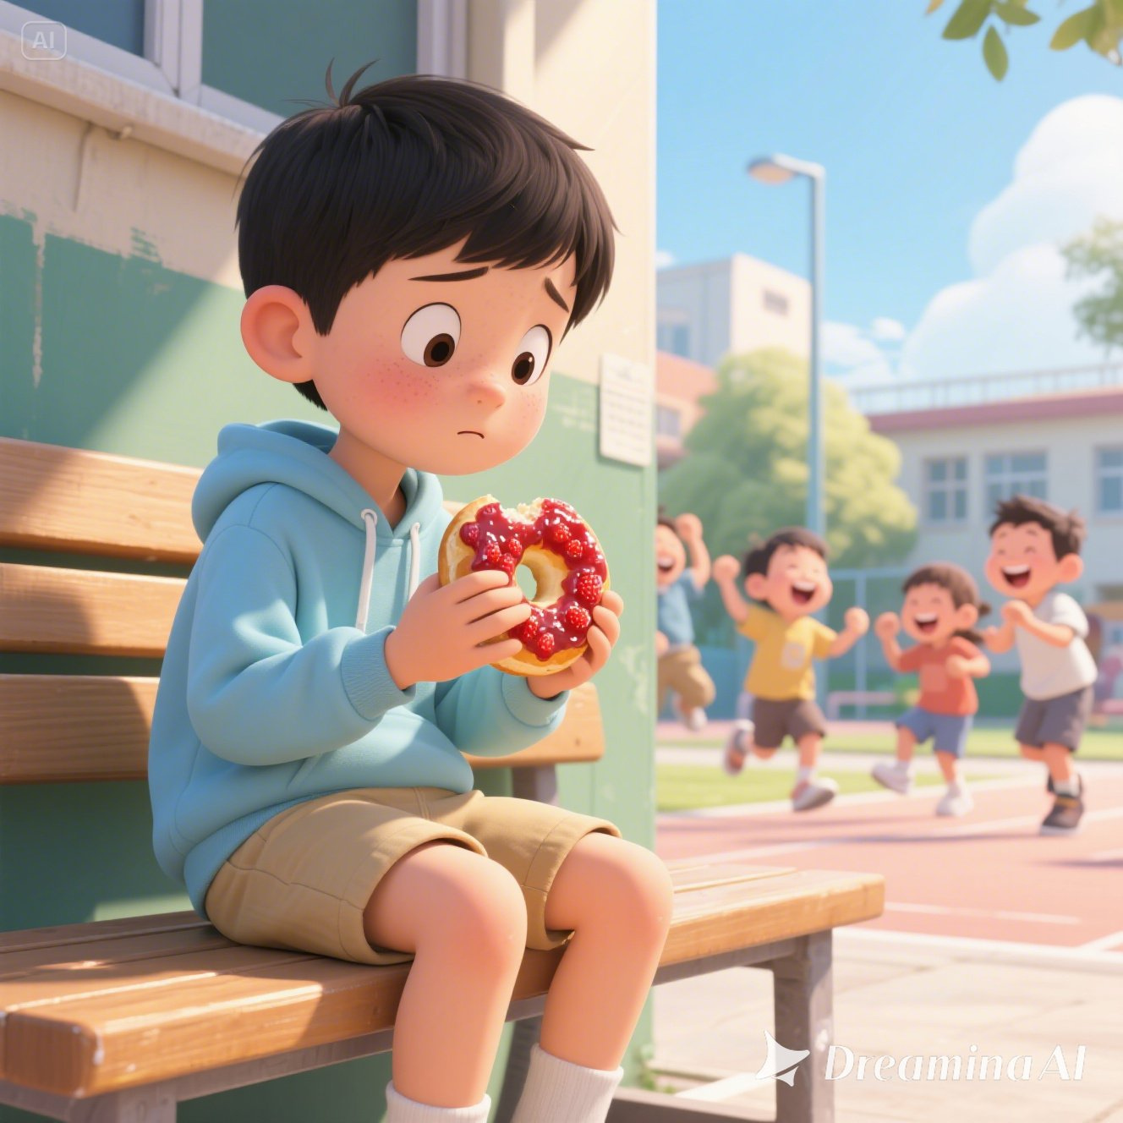
At break time, he chose to sit alone and munch on his favourite strawberry jam bagel.

On his second day, Ben was bullied by a classmate who was sitting in front of him. The bully’s name is Mike.
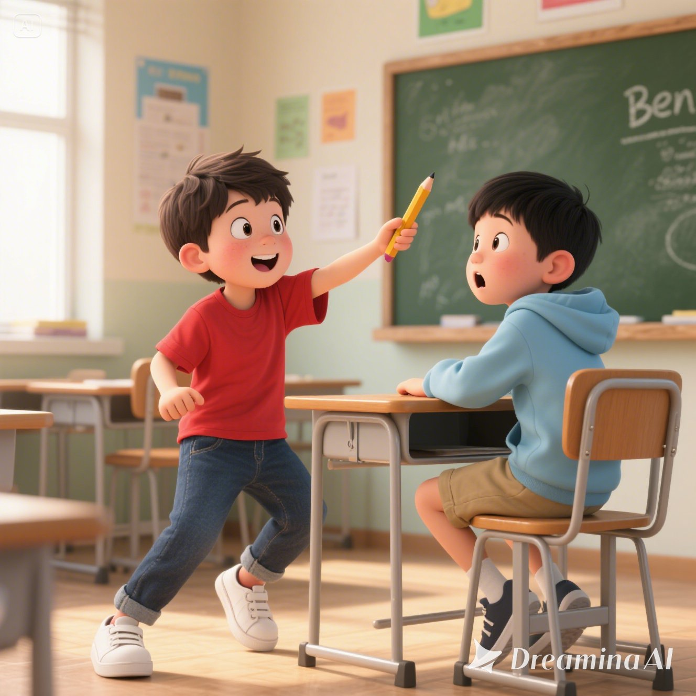
All day, Ben was bullied by Mike. First thing that Mike did was, he turned around to face Ben then snatched the pencil away.
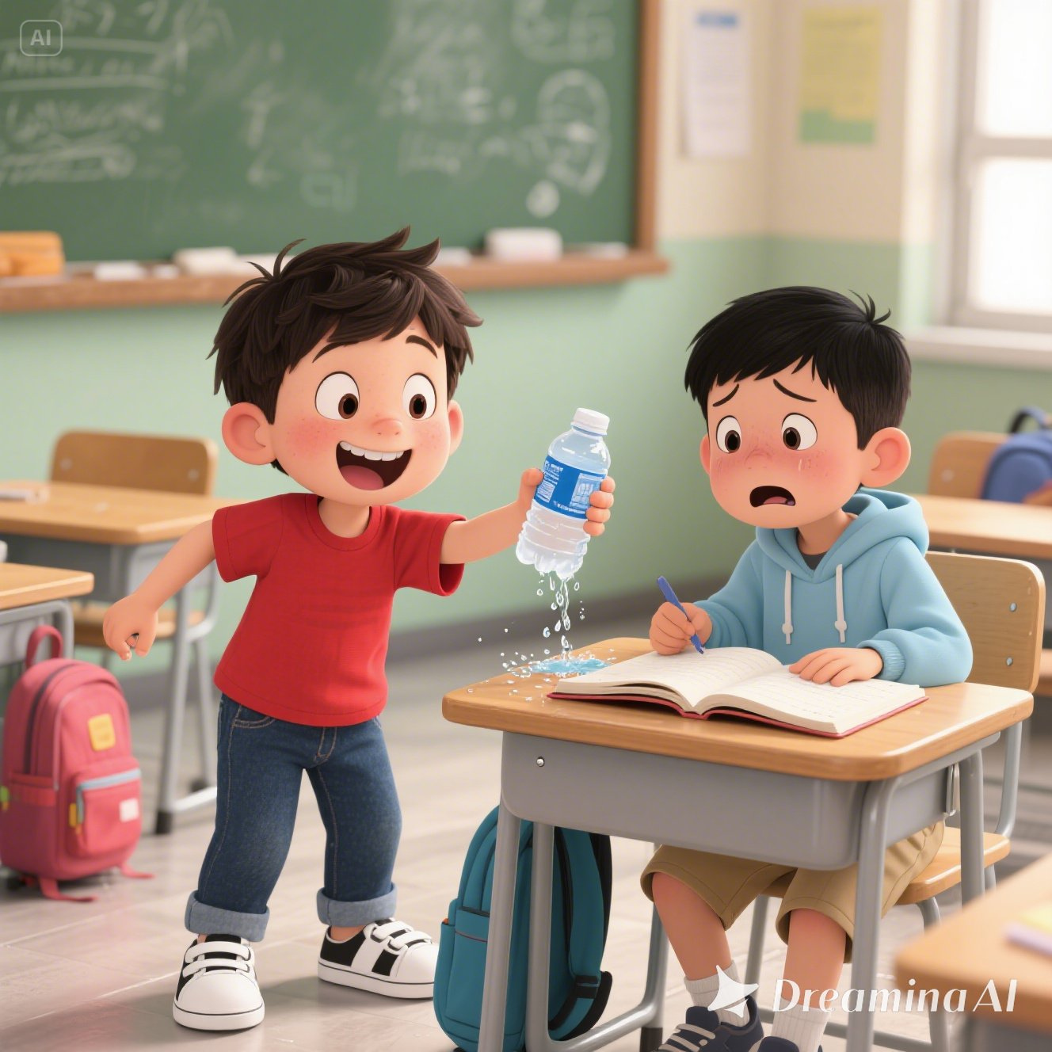
After that, Mike dripped water onto Ben’s book.
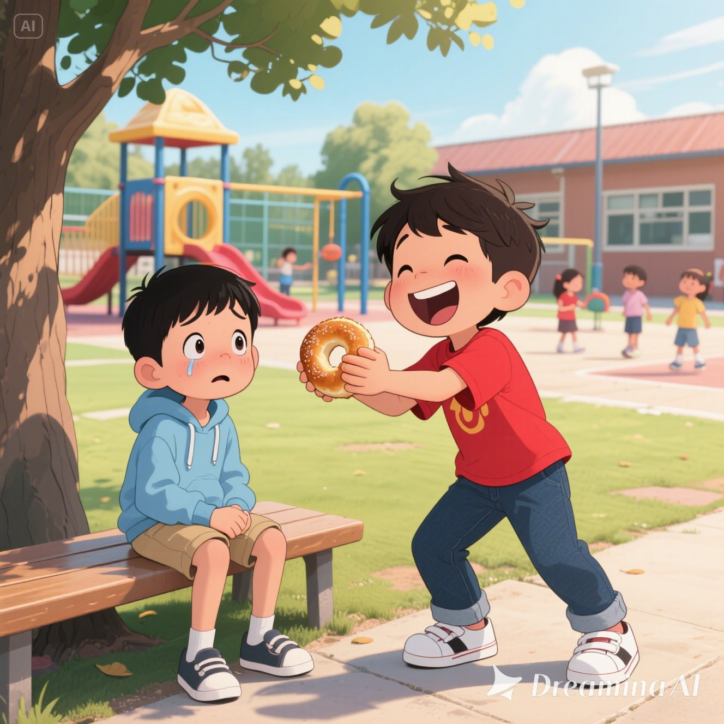
During break time, Mike ran up to Ben, laughed at him then snatched the bagel from his hands. How rude!

Mike said to Ben, “If you tell Miss Gloria about this, I will beat you up!”
That made Ben so afraid that he decided to stay quiet about this but he felt angry and hurt about what Ben did to him.
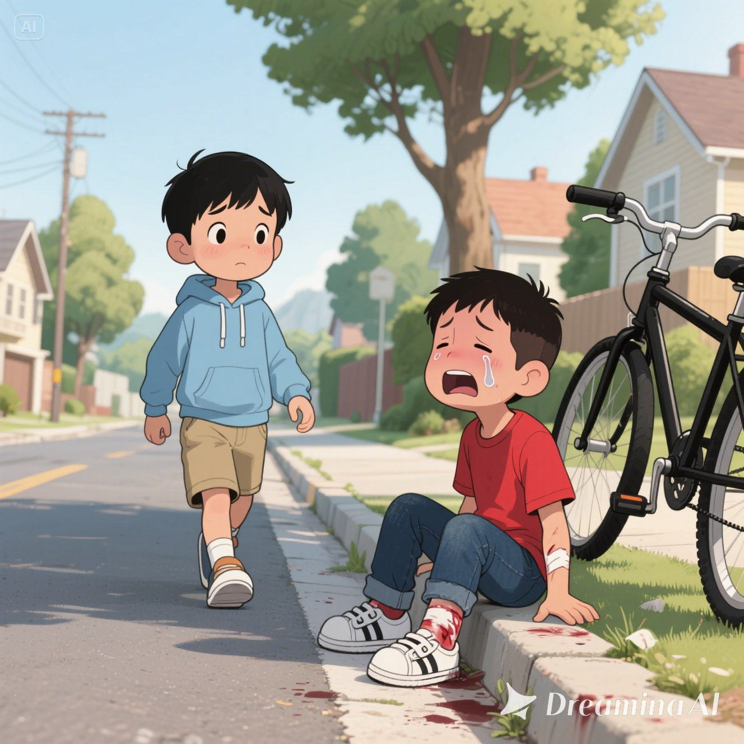
One day, as Ben was walking home, he saw Mike crying by the roadside.
Mike had fallen off his bicycle and his knees were bleeding.

Ben stood there and thought, “Should I help him?”
Then Ben remembered the story that his church teacher told him about. God showed grace and compassion to the people of Nineveh even though they had sinned against Him. This was Ben’s chance to show compassion.
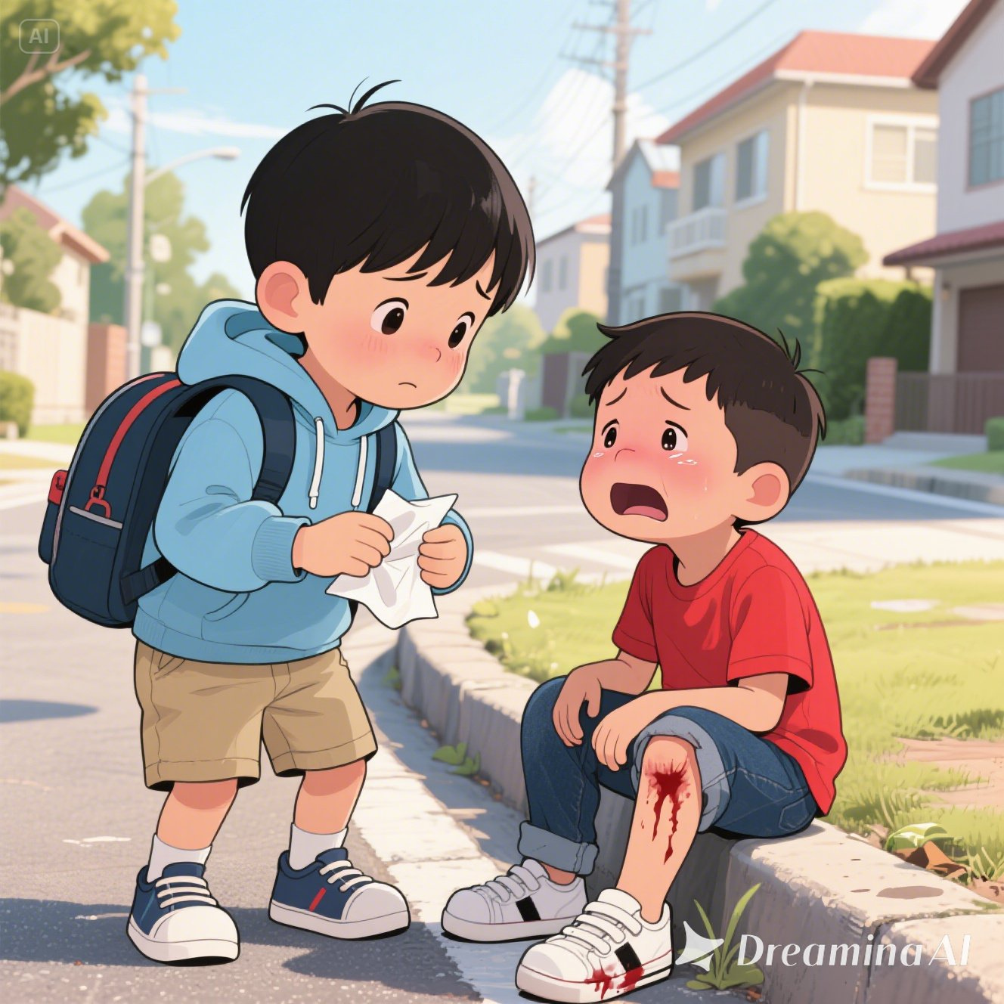
So, Ben took a deep breath and walked up to Mike. He took some tissue papers out from his bag and gave them to Mike.

Mike slowly stopped crying, he was shocked that Ben was helping him even though he was bullied all this while, he was curious and asked “Why are you helping me?”
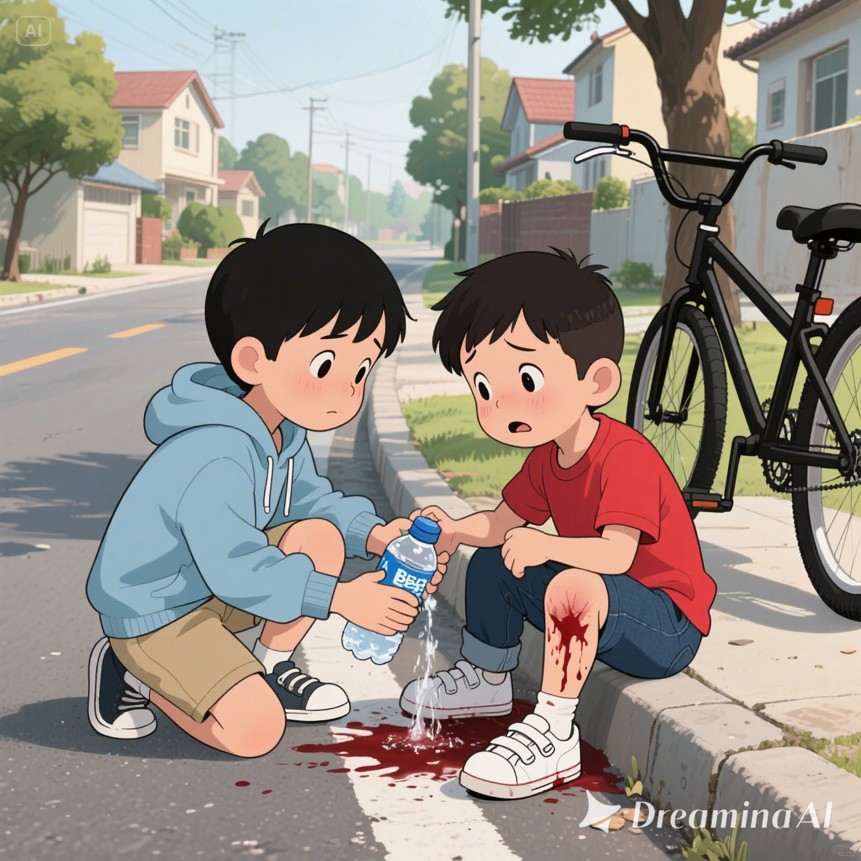
”Because my God showed me compassion when I did not deserve it. I am following what He has taught me because this is the right thing to do,” Ben answered in one breath while helping Mike to wash his bleeding knees with water from his water bottle.

“I’m very sorry for bullying you Ben. I will not do that any more.” said Mike.

From that day onwards, they became good friends and Mike followed Ben to church every weekend.
Game - Passing Jesus On
- Divide the children into 2 groups.
- Group 1 makes a circle. Group 2 make a circle inside if Group 1’s circle then face each other.
- Teacher says a sentence, “Jesus loves you!” and the children repeat it to their friend opposite them.
- Then teacher shouts, “Switch!” and the children take one step to their right, changing partners.
- Then repeat steps 3 and 4 with different sentences.
  - Our God is full of Grace.
  - Our God is full of compassion.
  - Jesus cares for you!
  - Jesus will protect you!
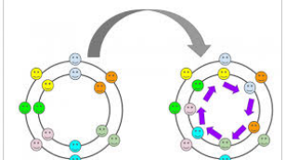

Craft
Materials | - Cut out flower template.  - Straw  - Glue  - Cellophane tape  - Colour pencils / crayons
Before Lesson | - Cut out the craft template.  - In the circle, make a small hole enough for the straw to pass through.  - Cut one end of the straw into 2 then push it through the hole.  - Open the ends of the straw and stick it to the circle using cellophane tape.
During Lesson | - Let the children colour the words and the flower.  - Glue the circle with the straw to the back of the flower.  - Read words together as they turn the flower.
Craft Template
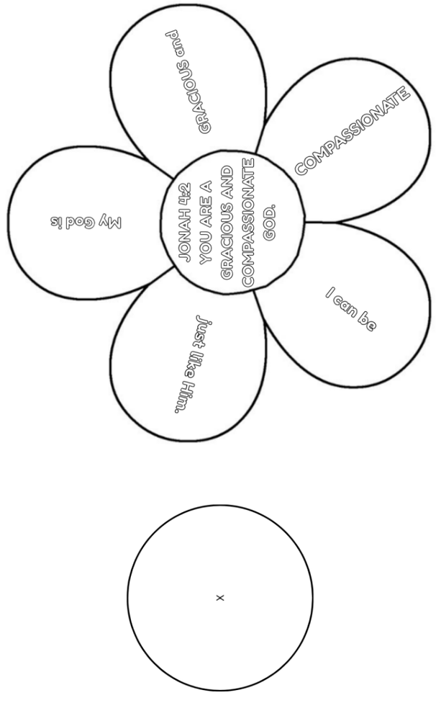
Closing
- Recite the memory verse with the children. Encourage them to practice at home.
- Ask the children if they have any prayer requests.
- Closing prayer: Dear Lord Jesus, I thank You for today’s story. I want to share about Your grace and compassion to my friends. Please help me. In Jesus name I pray, Amen.

