
Dear teacher,
All glory and honour be unto our loving Father in heaven. May you be filled with His love and peace as you prepare for the lesson.
Why was this new syllabus written?
- The main objective of this is so that God’s words are written on their hearts.
- Second objective is that the children can apply what they have learned about the verse in their daily lives.
- Third reason is so that as they grow up, when they face challenges, they will be able to have an impression of what they have learned and turn to God first.
Here are a few things you should do before you dive into the preparation:
- Spend time with God. Being connected to the Holy Spirit is important because we are imparting His teachings.
  - Pray
  - Sing praises
  - Read the bible passage reference.
While preparing:
- Decide the flow of your lesson. You don’t have to follow the traditional way of teaching.
  - Do the craft first so that you can use it during the Bible story.
  - Play the game first so that the kids can understand the lesson from their experience.
  - Pick and choose the activities. The stated activities, games and crafts are only suggestions. Feel free to make changes to any part of the lesson plan to suit your teaching style.
- Download the game or craft template if needed.
- Regarding the story part, use your preferred method to bring the message across.
  - Power Point Slides
  - Ready videos from the Internet
  - Puppets
  - Draw while telling the story
  - Enlarged pictures
  - Drama
  - Adding in a song or two
During the lesson, spend time to get to know the children.
- Use the time while they are doing craft or while waiting for their parents, take a chair and sit by the door and chat with them.
- Pray and ask the Holy Spirit to tell you which child you should approach for that day.
- Here are some openings that you can use, questions like the following let the child feel noticed, important and cared for.
  - “How was your week in school/at home?”
  - “I noticed you are wearing.../you brought.../you look.../you have a scar on your...”
  - “Just now you told us about...do you want to tell me more?”
  - “You were running around/disturbing your friend/looking at something/playing with something. How did you feel?”
- Pray with the child.
We hope that you will enjoy every bit of teaching these precious little ones. Let us remember that we are obeying Jesus’ command to feed His sheep (John 21:15-17). May you be filled with the Holy Spirit and grow closer to the Lord.



Week | 2
Bible Passage Reference | Jonah 3 and 4
Topic | Compassion
Focus | Bible story 1 - Jonah 3
Memory Verse | Jonah 4:2 You are a gracious and compassionate God.
Pre-lesson
- Opening prayer - Dear Lord, I praise Your name for You are a gracious and compassionate God. Today, I will be learning more about You. Please bless our class time. I give my heart, help me to stay focused today. In Jesus’ name I pray, Amen!
- Short discussion
  - Do you remember what is “Grace” and “Compassion”?
  - Do you know Jonah’s story?
  - What happened after he warned the town of Nineveh that God will destroy them?
Lesson
- Recite the memory verse with the children.
- Present the Bible story. You can use your preferred method of bringing out the story or refer to the simplified version of the story in the following page.
- Discussion questions:
  - What did the people of Nineveh do that made God angry? (They fought, told lies, disobeyed, hurt others, and didn’t worship God.)
  - Did they repent after they heard Jonah’s words? (Yes, even the King of the land repented.)
  - When God saw they were repented, did He forgive them? (yes, God forgave them and did not punish them.)
Simplified Version of the Story
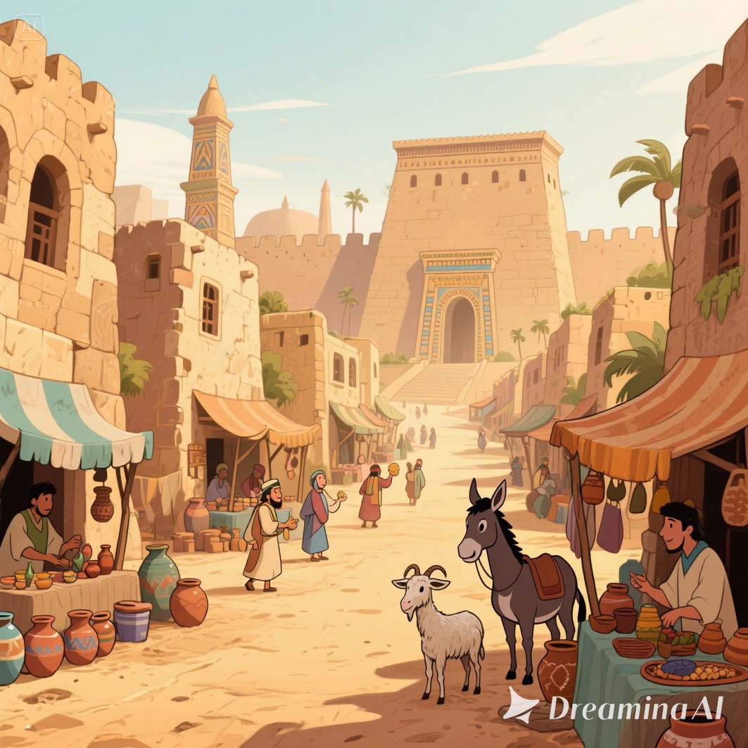
A long, long time ago, there was a big, busy city called Nineveh. So many people lived there, but they were doing many bad things.
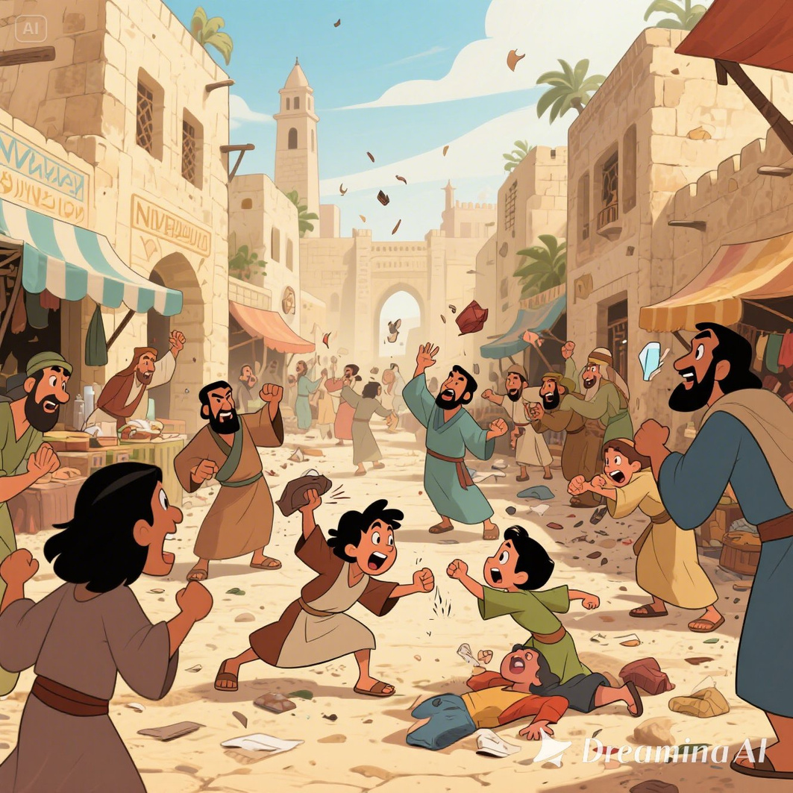
They fought, told lies, disobeyed, hurt others, and didn’t worship God. God saw all the bad things they did, and His heart was very sad.
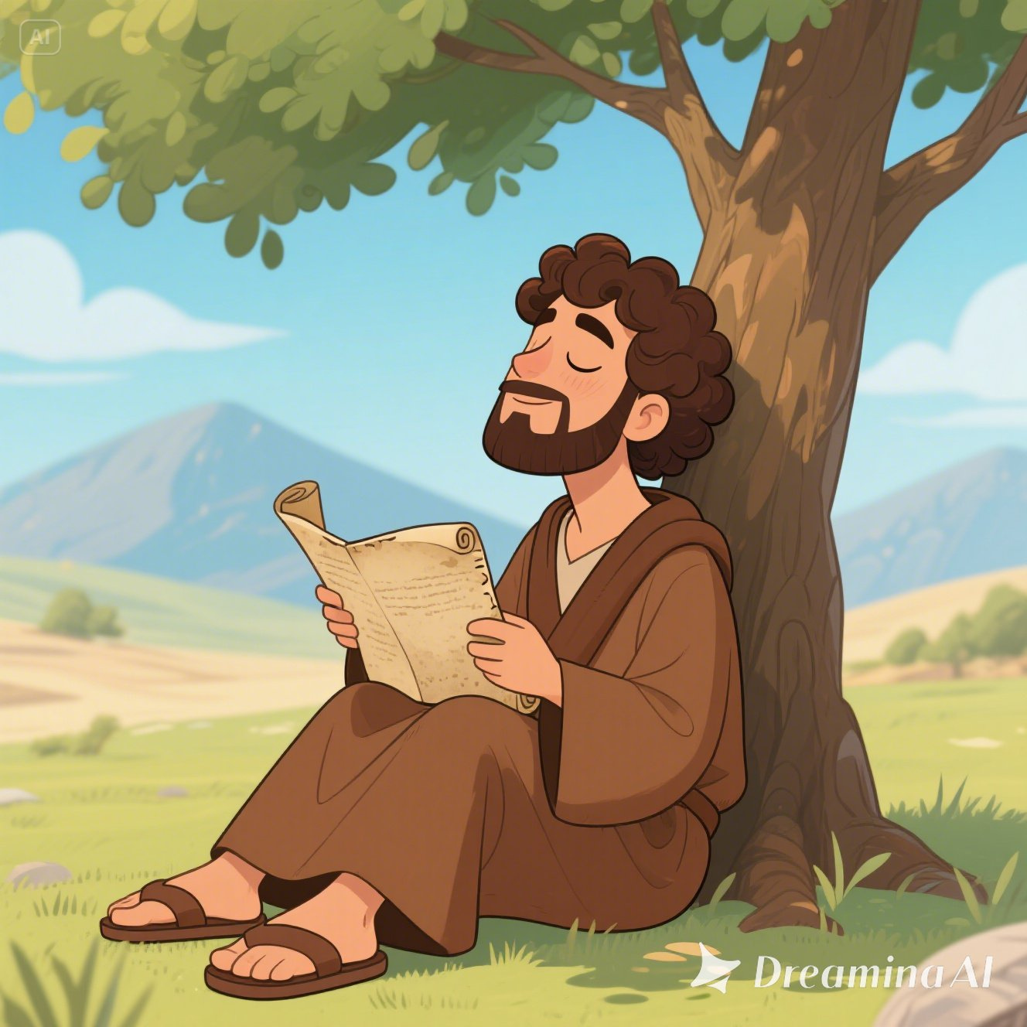
He loved the people, but He didn’t like the bad things they were doing. So, God called His prophet—Jonah.
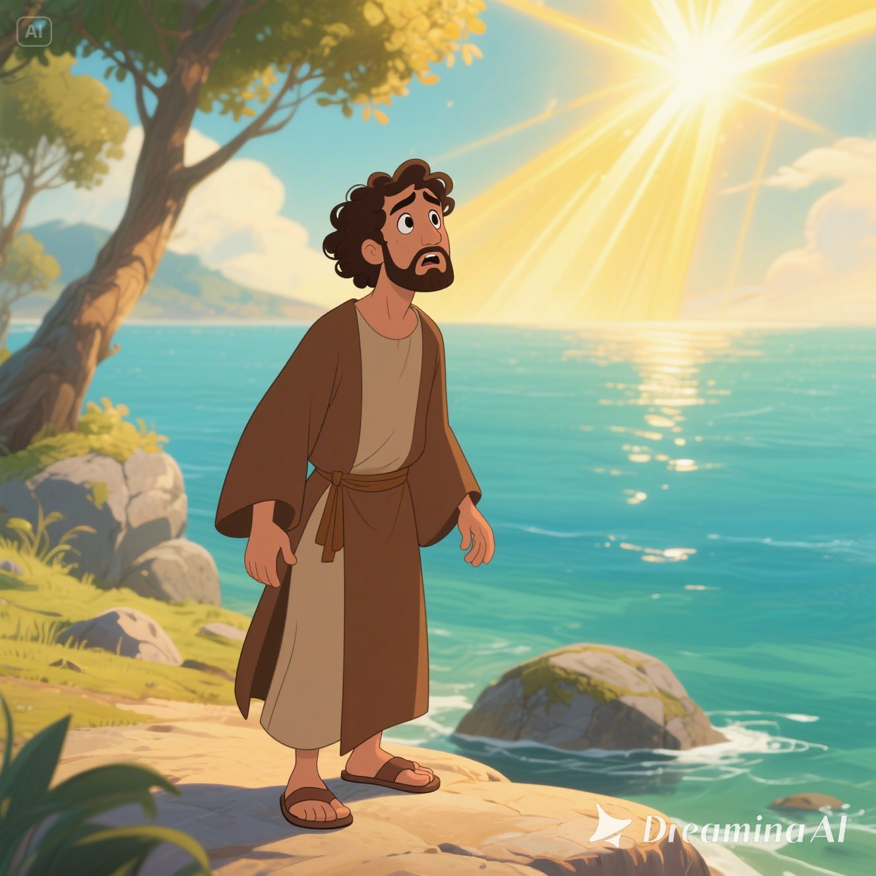
He said, “Jonah, go and tell the people of Nineveh:
‘In 40 days, if you don’t say sorry and stop doing wrong, this city will be destroyed!’”
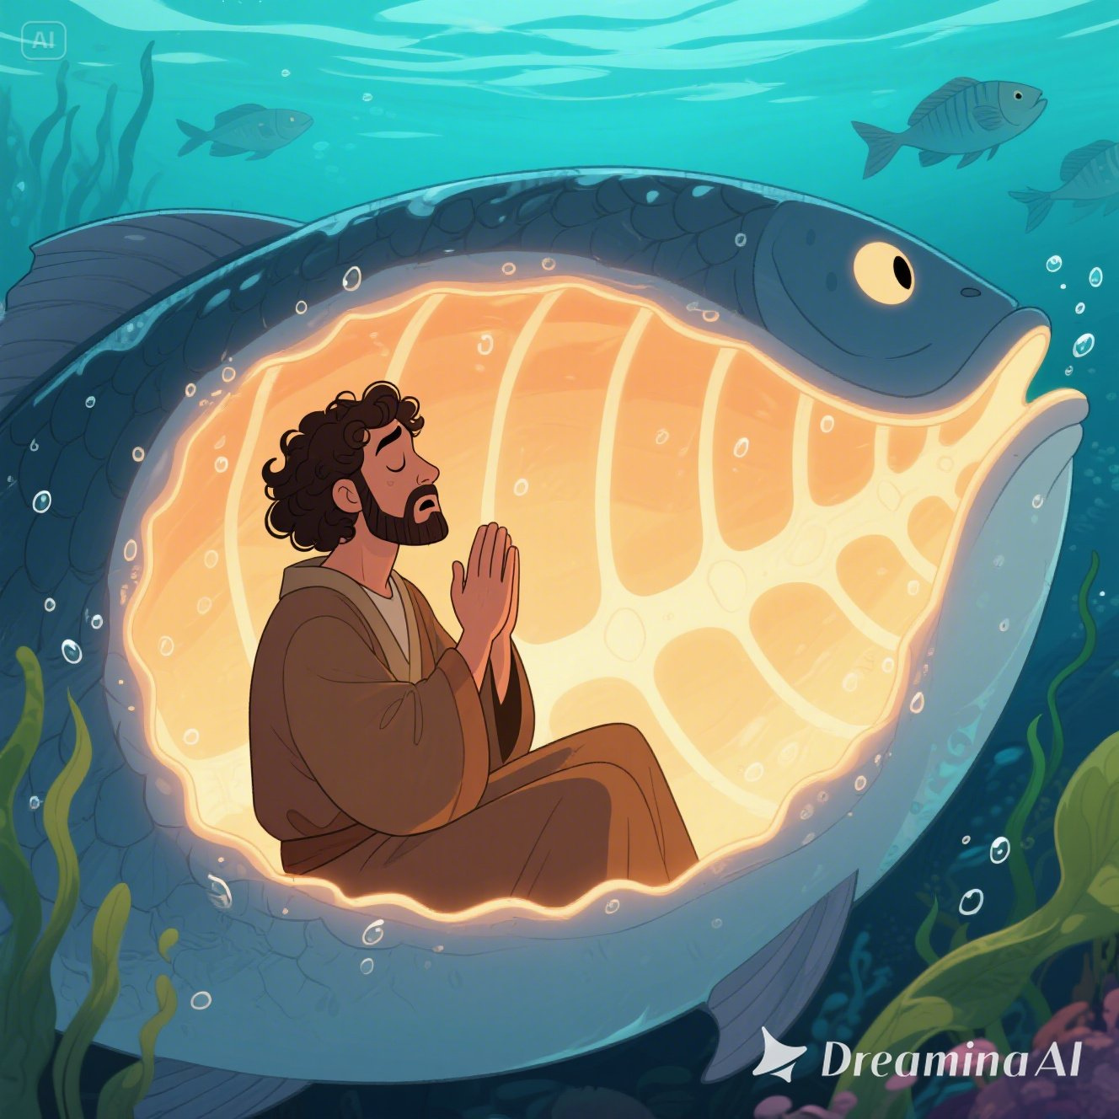
Jonah didn’t want to go at first, but later he listened to God.
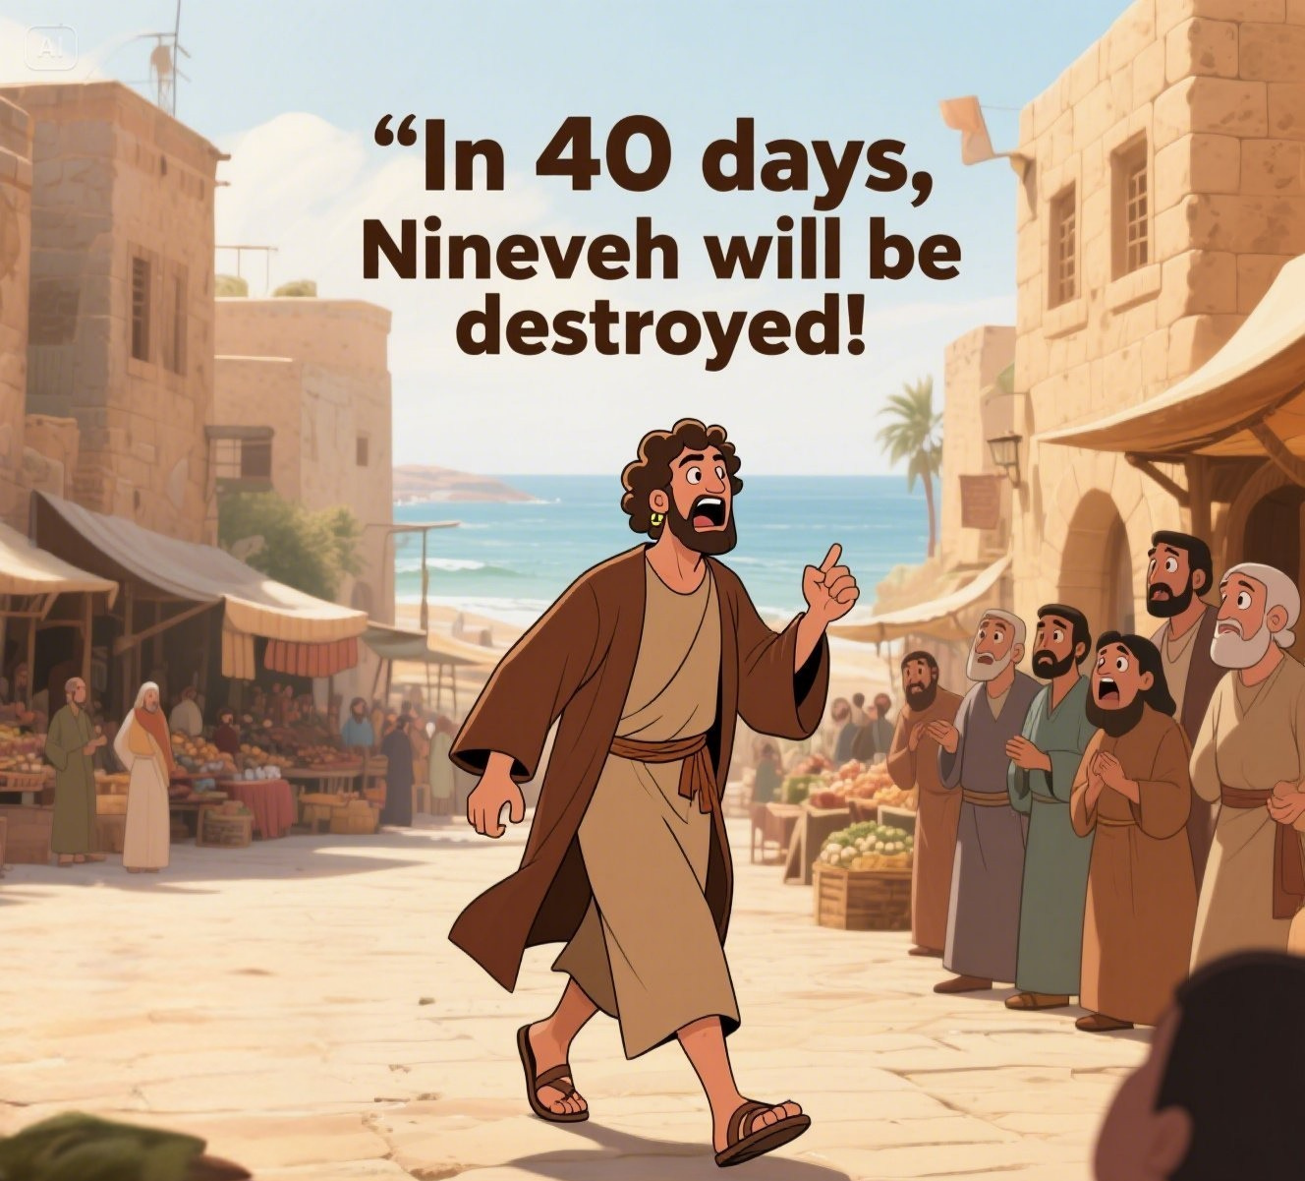
He walked into Nineveh and shouted, “In 40 days, Nineveh will be destroyed!”
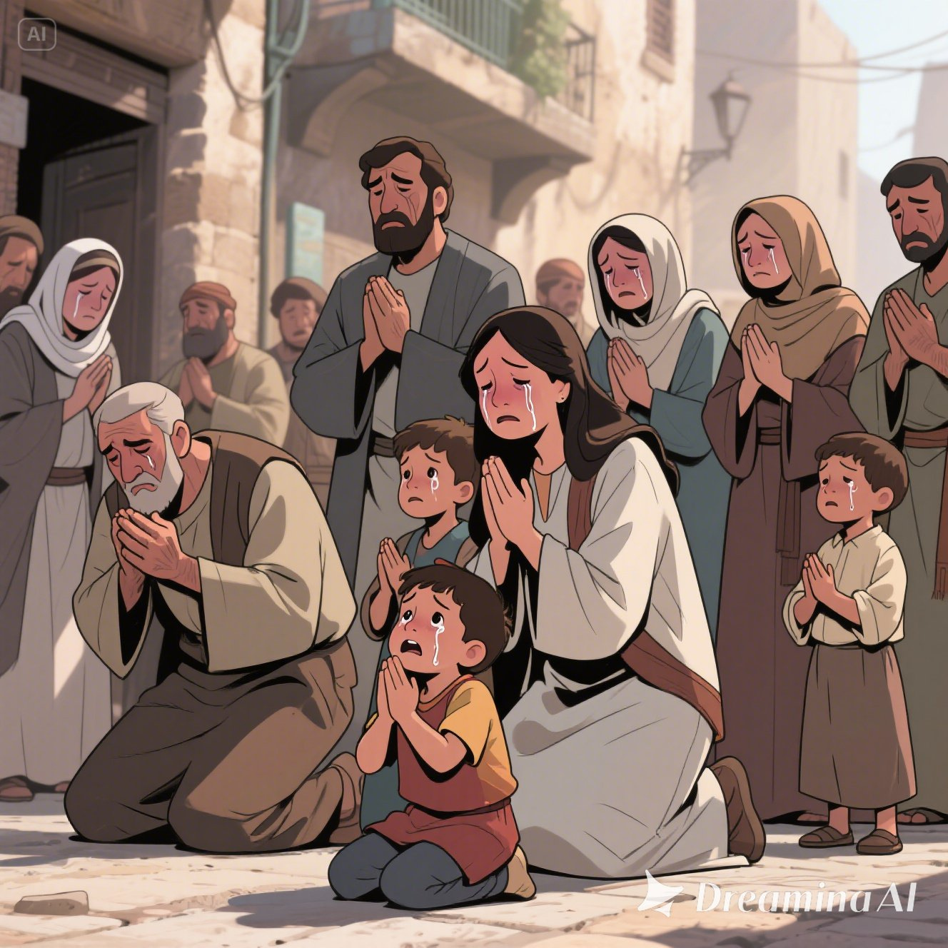
The people in the city heard Jonah’s words. They weren’t angry. They were shocked and sad!
“Oh no! We’ve done so many bad things!” they said. “We need to repent now. Say sorry to God and turn to Him right now!”
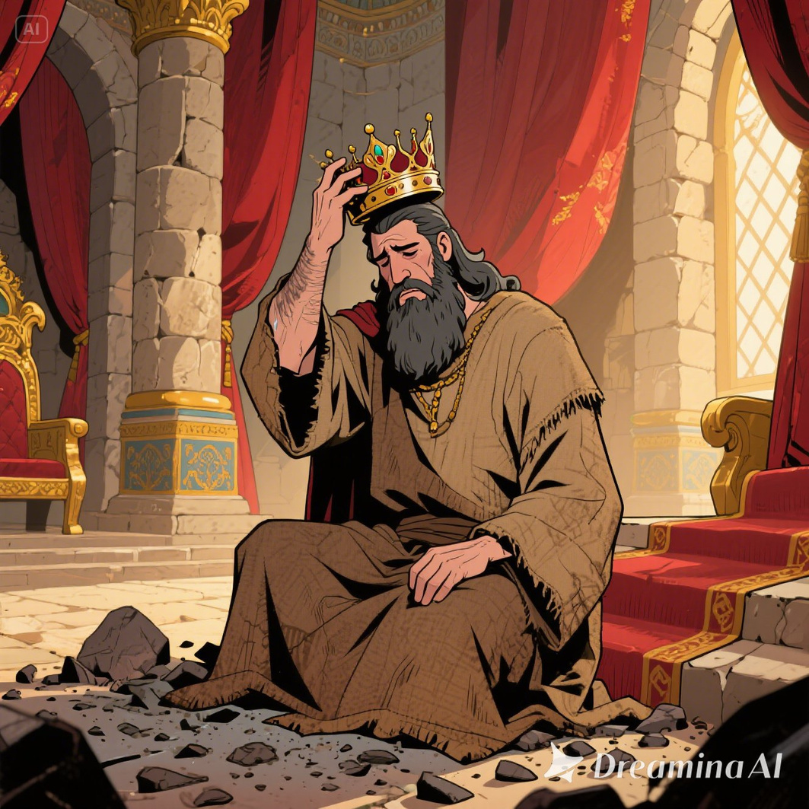
Even the king heard the message. He got off his throne, took off his fancy clothes, and put on rough, plain clothes. He sat in ashes and told everyone: “Don’t eat anything—not adults, not kids, not even the animals! We must pray and say sorry to God. Let’s stop doing wrong and ask Him to forgive us.”
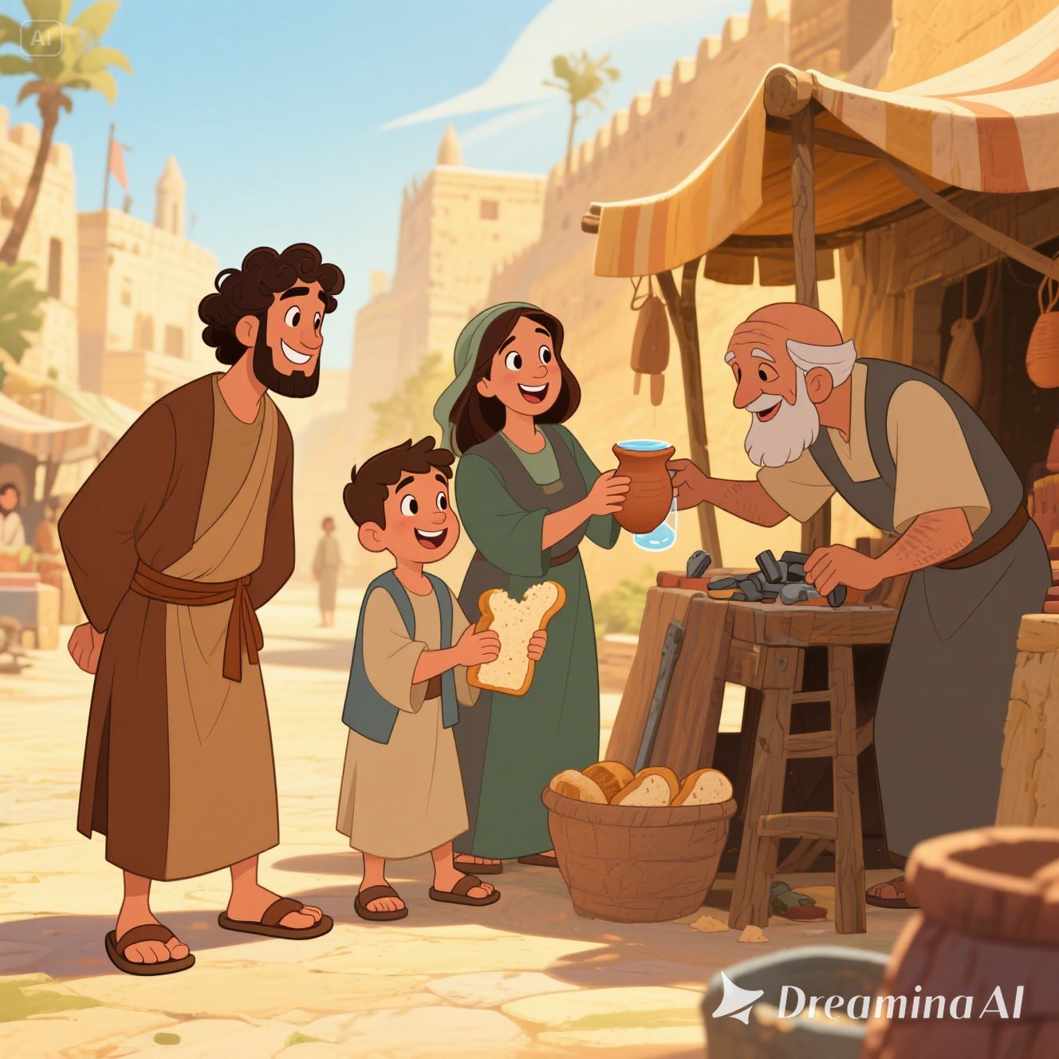
The whole city began to change! They stopped fighting, stopped lying, and started being kind and helpful.
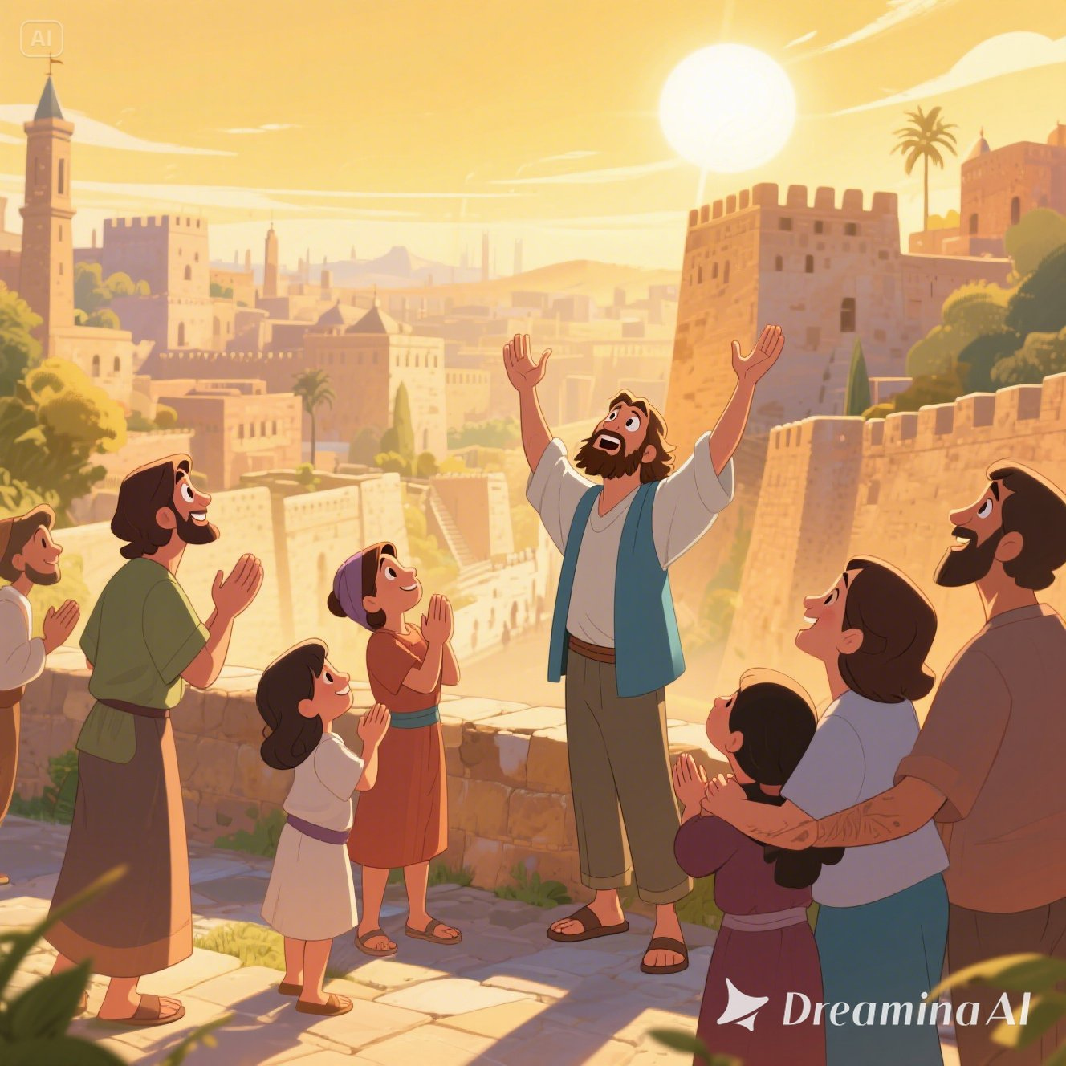
Best of all, they all repented and prayed to God with true hearts. God saw how much they had changed. He was so happy! He said, “They have turned from their bad ways. I am a kind and loving God. I will not destroy Nineveh.” And so, the city was safe. The people kept praying, kept doing good things, and did not go back to being bad and naughty again.
Game - Build a Shelter
- Divide the children into groups of 4 to 5.
- Give them 4 chairs and a bed sheet.
- Ask the kids to build a shelter.
- Optional: provide some torch lights or fairy lights and turn off the classroom lights.
- Explain: This tent represents God’s Grace, it shelters us from harm. We know that we can feel safe under the covering of God. So, what we need to do is accept Jesus into our lives and let Him protect us!


Craft
Materials | - Print out of craft template.  - Colour pencils or crayons.  - Glue
Before Lesson | - Cut out the craft template of the whale.  - Accordion-fold the dotted strip.
During Lesson | - Children are to colour the whale and memory verse.  - Fold the paper to join the head and the tail of the whale to view a complete whale.
Craft Template
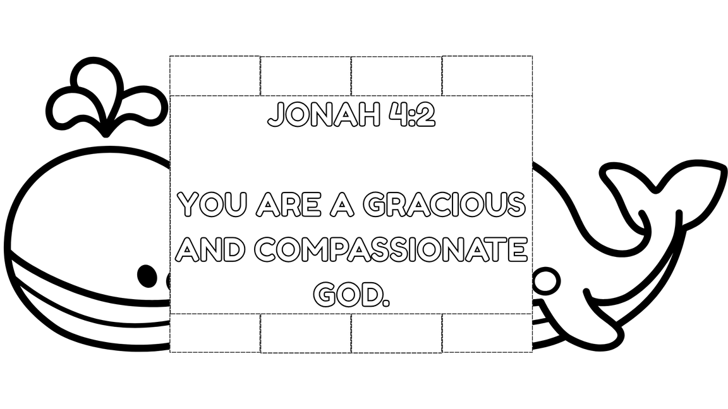

Closing
- Recite the memory verse with the children. Encourage them to practice at home.
- Ask the children if they have any prayer requests.
- Closing prayer: Dear Jesus, thank You for today’s lesson. I learned that You are a gracious and compassionate God. Jesus, I am sorry for what I have done wrong, please forgive me. In Jesus name I ask and pray, amen.

