
Dear teacher,
All glory and honour be unto our loving Father in heaven. May you be filled with His love and peace as you prepare for the lesson.
Why was this new syllabus written?
- The main objective of this is so that God’s words are written on their hearts.
- Second objective is that the children can apply what they have learned about the verse in their daily lives.
- Third reason is so that as they grow up, when they face challenges, they will be able to have an impression of what they have learned and turn to God first.
Here are a few things you should do before you dive into the preparation:
- Spend time with God. Being connected to the Holy Spirit is important because we are imparting His teachings.
  - Pray
  - Sing praises
  - Read the bible passage reference.
While preparing:
- Decide the flow of your lesson. You don’t have to follow the traditional way of teaching.
  - Do the craft first so that you can use it during the Bible story.
  - Play the game first so that the kids can understand the lesson from their experience.
  - Pick and choose the activities. The stated activities, games and crafts are only suggestions. Feel free to make changes to any part of the lesson plan to suit your teaching style.
- Read the lesson plan.
- Regarding the story part, use your preferred method to bring the message across.
  - Power Point Slides
  - Ready videos from the Internet
  - Puppets
  - Draw while telling the story
  - Enlarged pictures
  - Drama
  - Adding in a song or two
During the lesson, spend time to get to know the children.
- Use the time while they are doing craft or while waiting for their parents, take a chair and sit by the door and chat with them.
- Pray and ask the Holy Spirit to tell you which child you should approach for that day.
- Here are some openings that you can use, questions like the following let the child feel noticed, important and cared for.
  - “How was your week in school/at home?”
  - “I noticed you are wearing.../you brought.../you look.../you have a scar on your...”
  - “Just now you told us about...do you want to tell me more?”
  - “You were running around/disturbing your friend/looking at something/playing with something. How did you feel?”
- Pray with the child.
We hope that you will enjoy every bit of teaching these precious little ones. Let us remember that we are obeying Jesus’ command to feed His sheep (John 21:15-17). May you be filled with the Holy Spirit and grow closer to the Lord.


Overview
Week | 1
Bible Passage Reference | Jonah 3 and 4
Topic | Grace and Compassion
Focus | Introduction
Memory Verse | Jonah 4:2 You are a gracious and compassionate God.
Pre-lesson
- Opening prayer: Dear Lord Jesus, I praise You for You are my Lord and Saviour. Now I am going to learn about Your teachings, please bless my little heart, ears and eyes. In Jesus’ name I pray. Amen!
- Short discussion
  - Have you ever received a gift from someone?
  - Did you do anything before receiving the gift?

Lesson
- Recite the memory verse with the children.
- Explain “Grace” and “Compassion.”
- Refer to attached pictures. You can ask the children to observe the picture and tell you what they see.
  - Grace = A gift that you did not earn - friendship with God.
    - Picture 1 - A child helping his mom sweep the floor. His mum rewards him with ice-cream.
    - Picture 2 - A child’s grandfather gives him an ice-cream and just says, "I love you."
    - Explanation: The child in Picture 1 deserves the ice-cream because he worked for it. The child in Picture 2 deserves the ice-cream even though he did not do anything for his grandfather. His grandfather gives the boy an ice-cream just because he loves him. Same as our God, He gave us eternal life through Jesus even though we are sinners. We do not deserve this love, but God still gives it to us because He loves us.
  - Compassion = Being kind to others.
    - Picture 1: A girl standing by the roadside, laughing at another girl who is crying because she fell from her bicycle.
    - Picture 2: A girl helping another girl who fell from the bicycle.
    - Explanation: The girls in Picture 1 did not show compassion to the girl who fell down, but the girl in Picture 2 did. Our God is a compassionate God, when we go through times that are down and sad, our God will help us by giving us peace and comfort. We know that we have peace and comfort because God has promised us He will always be there for us. We are confident in that because God never lies.
- Recite the memory verse with the children. Encourage them to practice at home.
Pictures to explain Grace and Compassion
Grace Picture 1
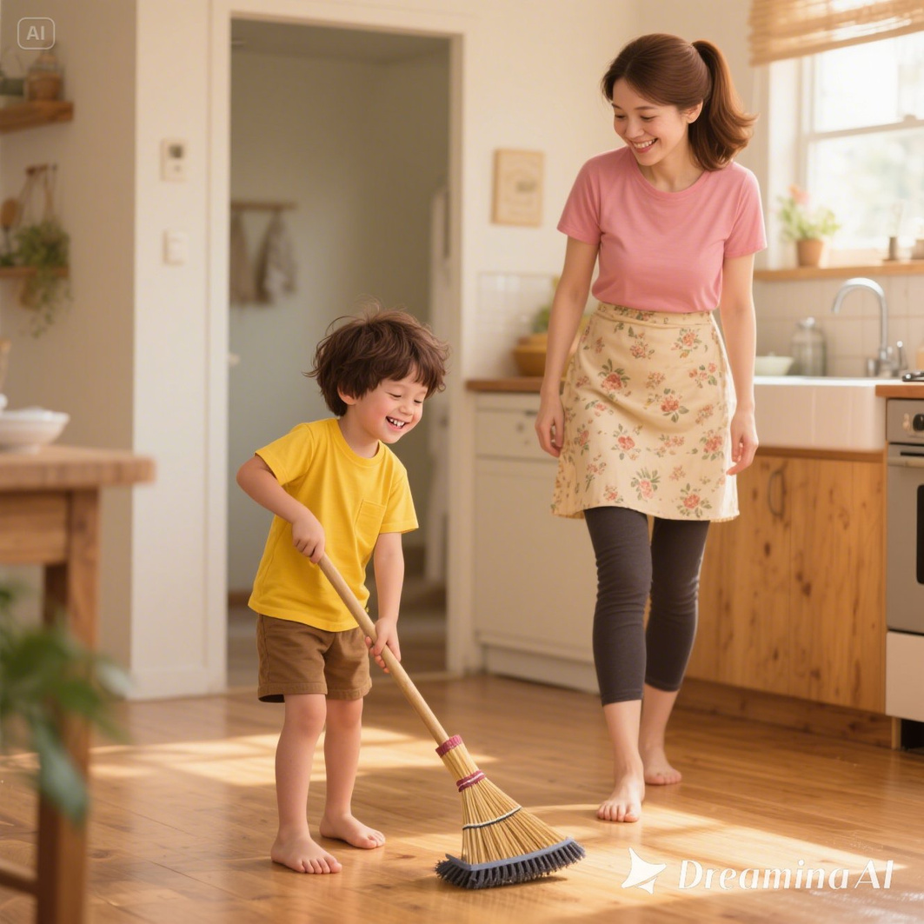


Grace Picture 2
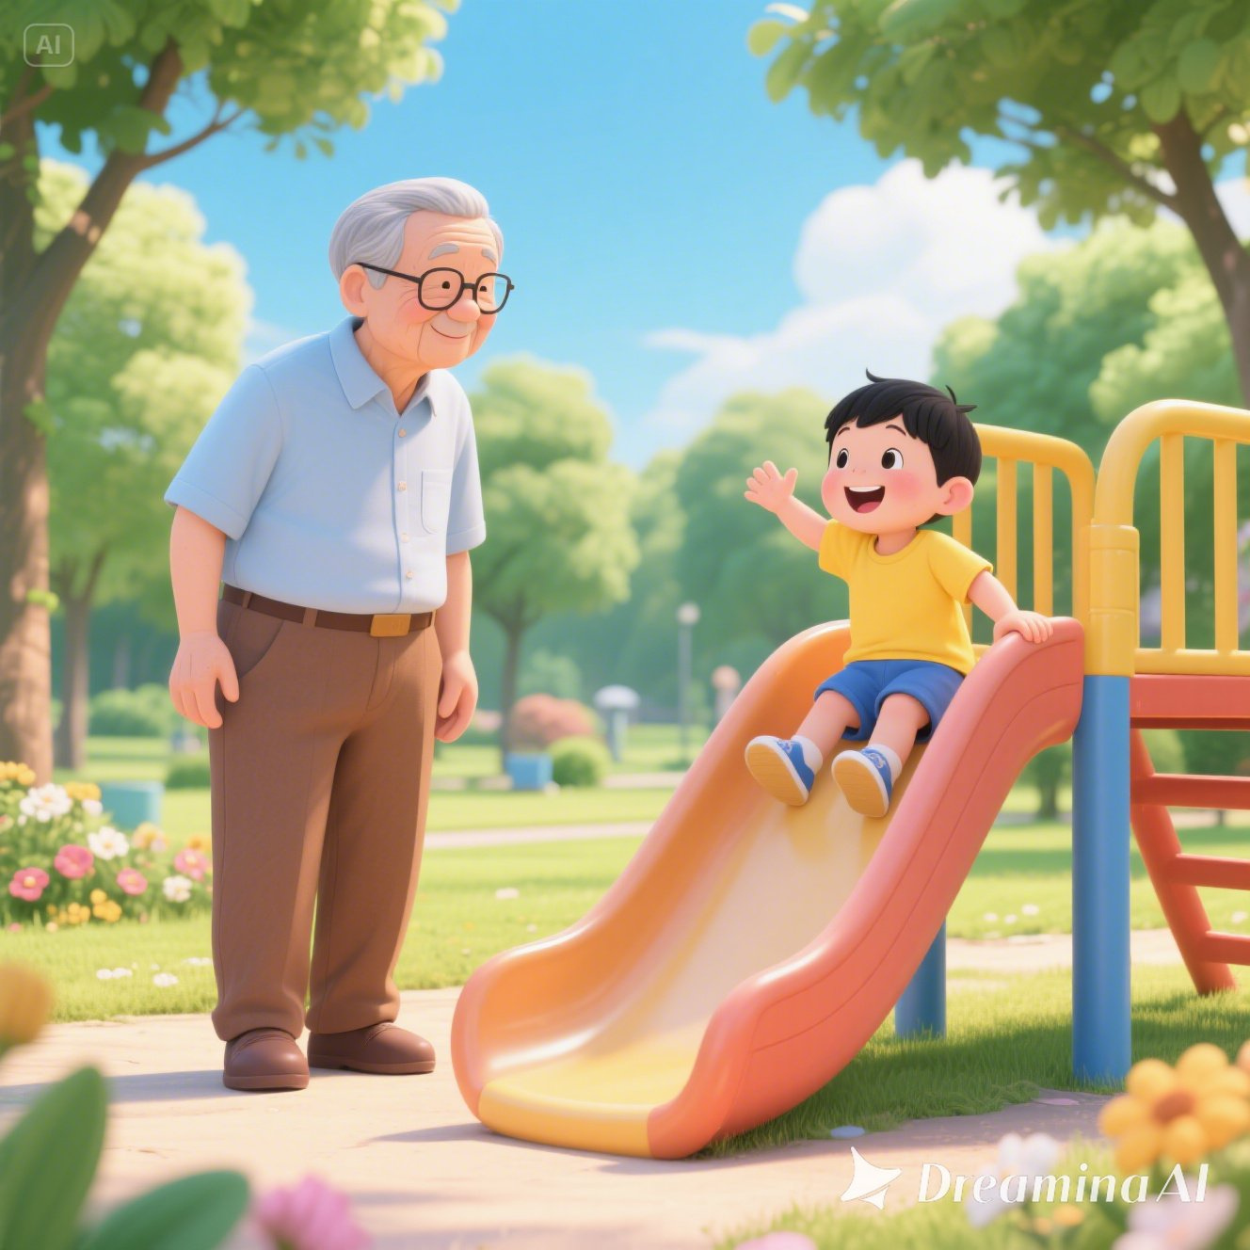


Compassion Picture 1
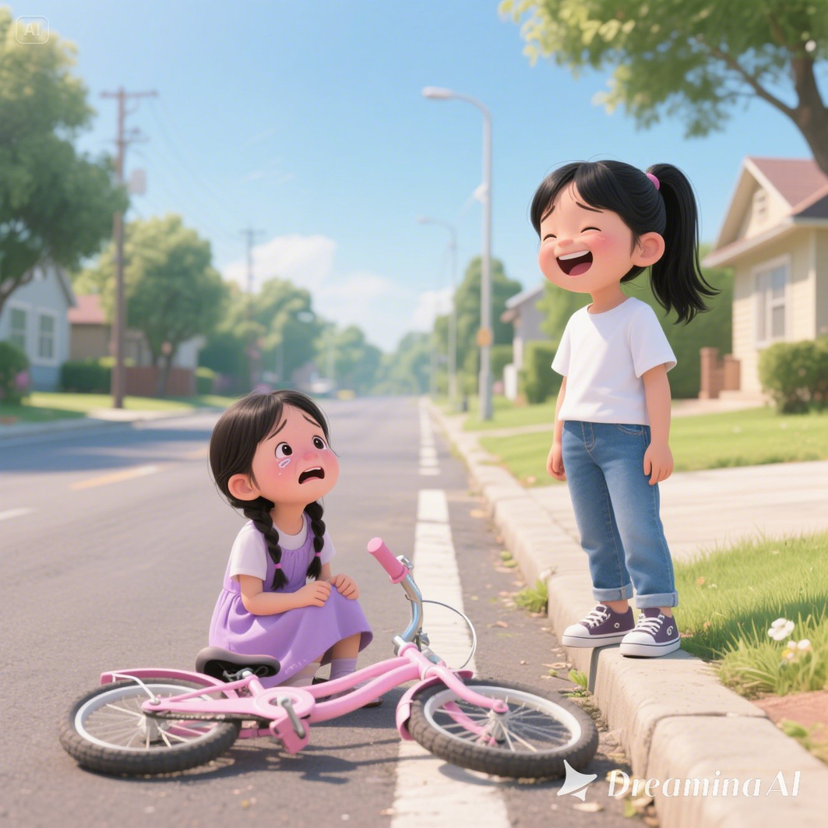

Compassion Picture 2
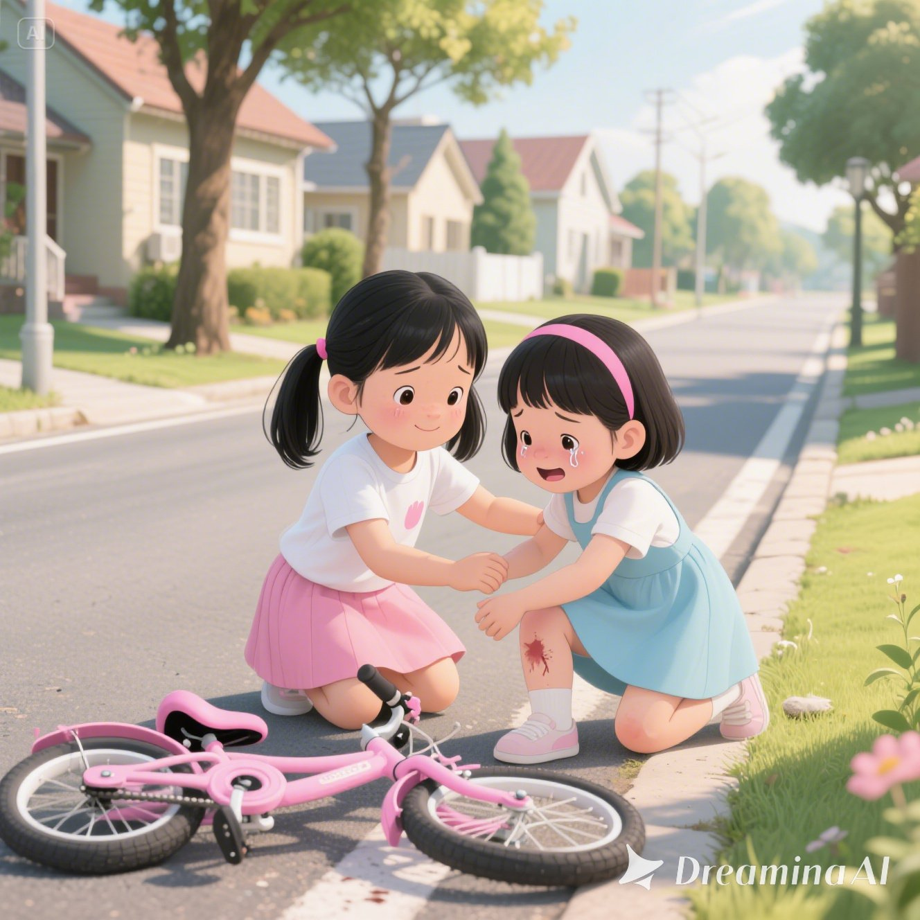

Game - Memory verse puzzle
- Assist the 4 and 5-year-olds.
- Allow the 6-year-olds to attempt the puzzle by themselves.
- Another option is to print a copy on thick paper, cut the puzzle out for each child to bring home.
Memory Verse Puzzle
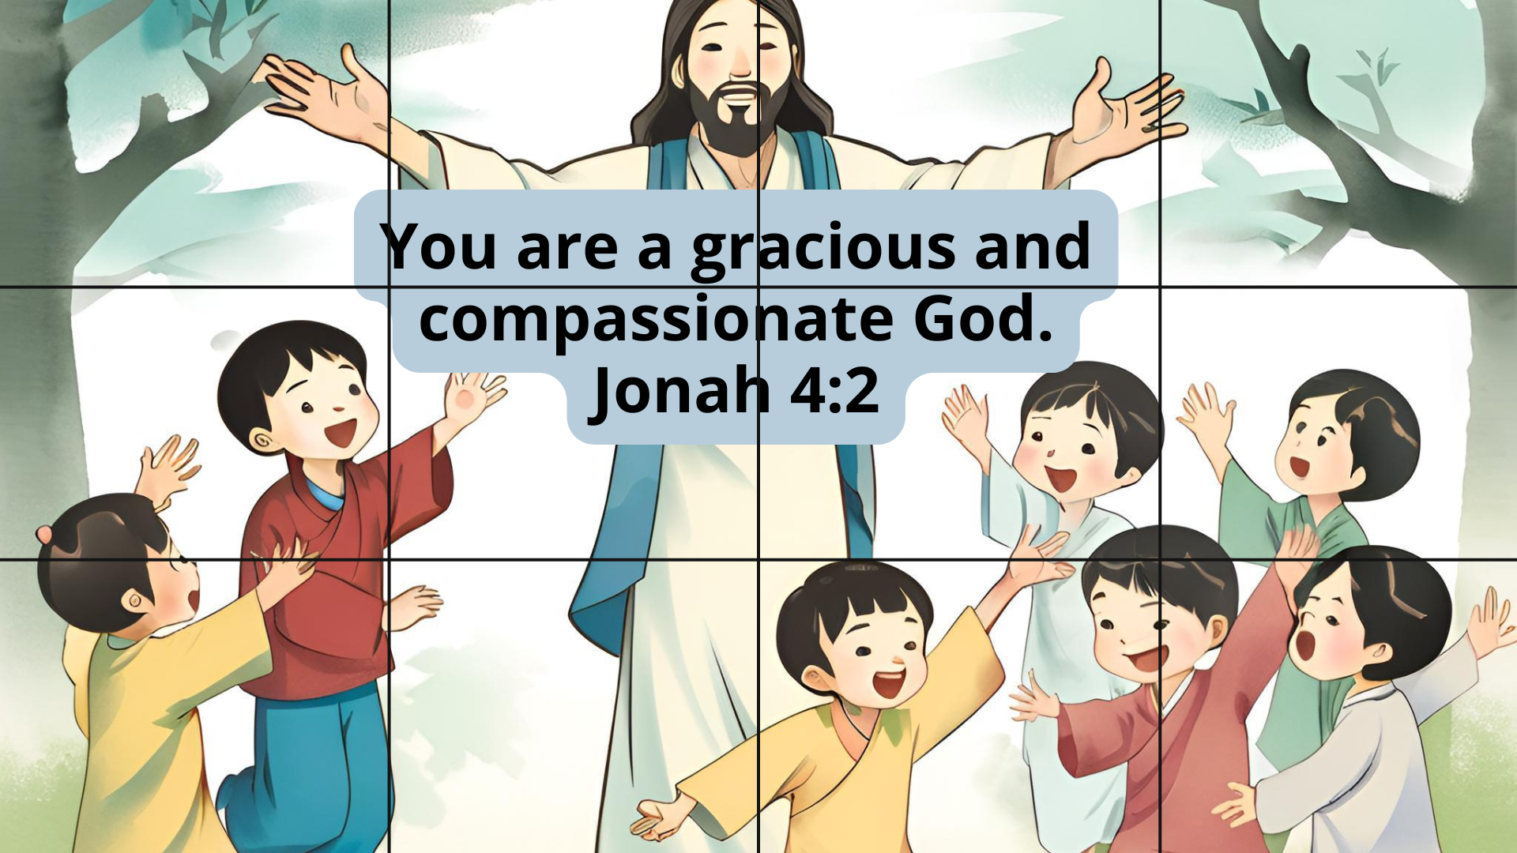

Craft
Option 1: Hanging memory verse paper plate
Materials | - Print out of craft template.  - Paper plate,  - Colour pencils or crayons  - Glue  - 12cm ribbon
Before Lesson | - Print out and cut out the craft template.  - Punch a hole at the top of the paper plate.
During Lesson | - Let the children colour Picture 2 of Grace and Compassion slides. Then glue it to one side of the paper plate.  - Colour the memory verse, then glue it to the other side of the paper plate.
Option 2: Colouring page
Download and compile the pictures to print out.
Craft Template
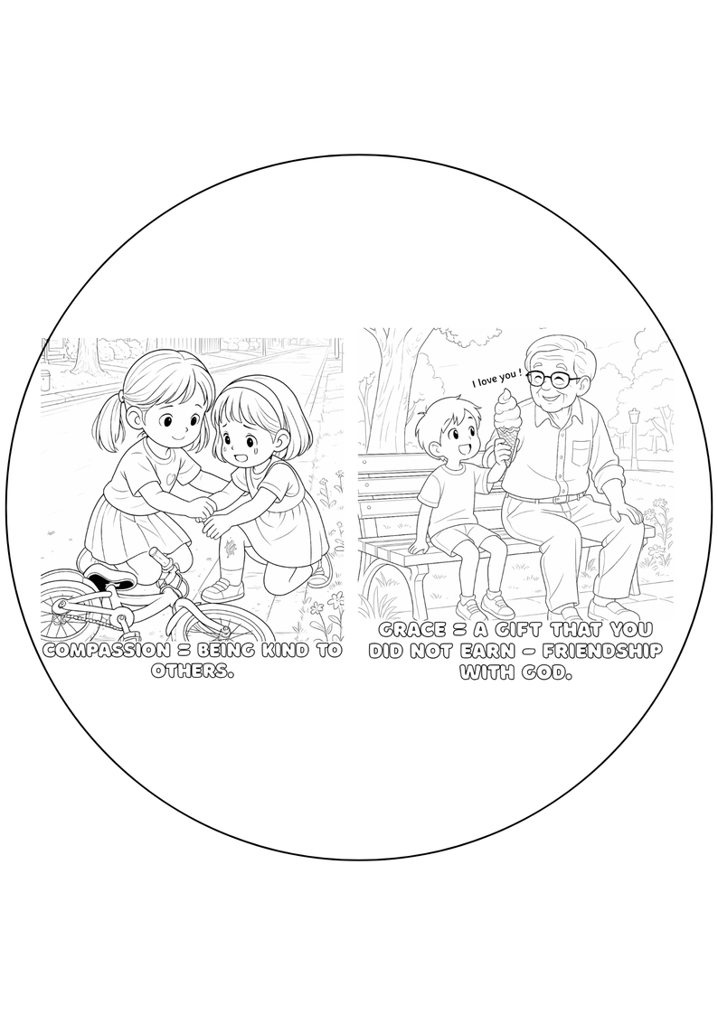
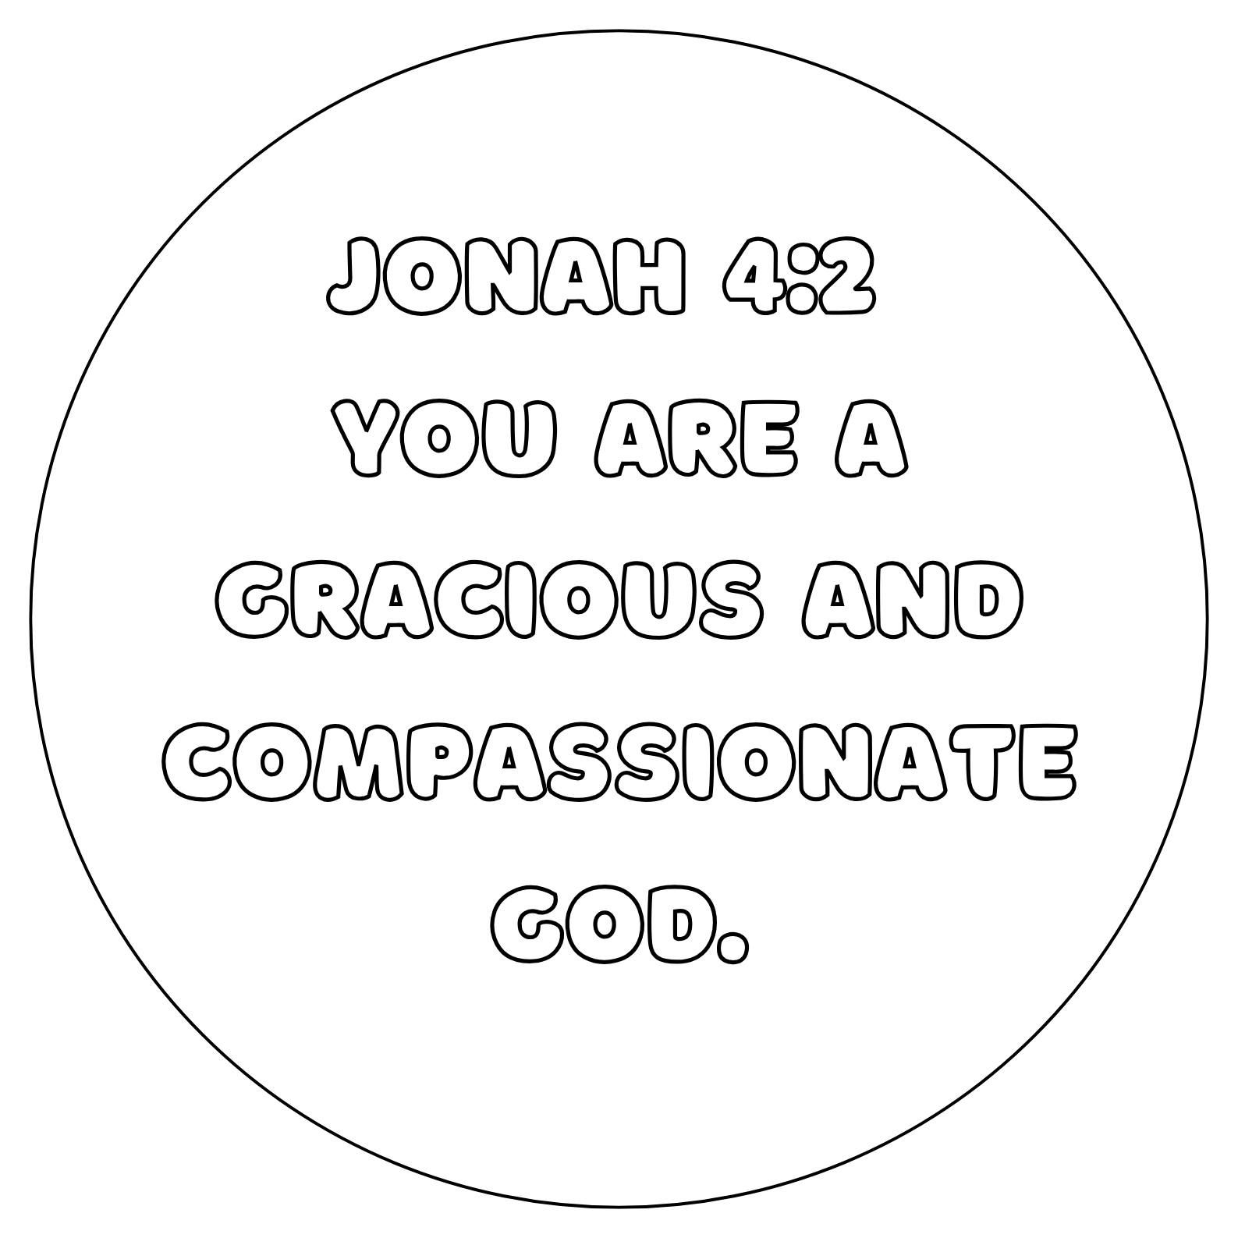

Closing
- Recite the memory verse with the children. Encourage them to practice at home.
- Ask the children if they have any prayer requests.
- Closing prayer: Dear Father, You are a gracious and compassionate God. Thank you for accepting me even though I am a sinner. Teach me to walk in Your ways. In Jesus name I pray, Amen.

