User Manual of «MiJia» vacuum cleaner
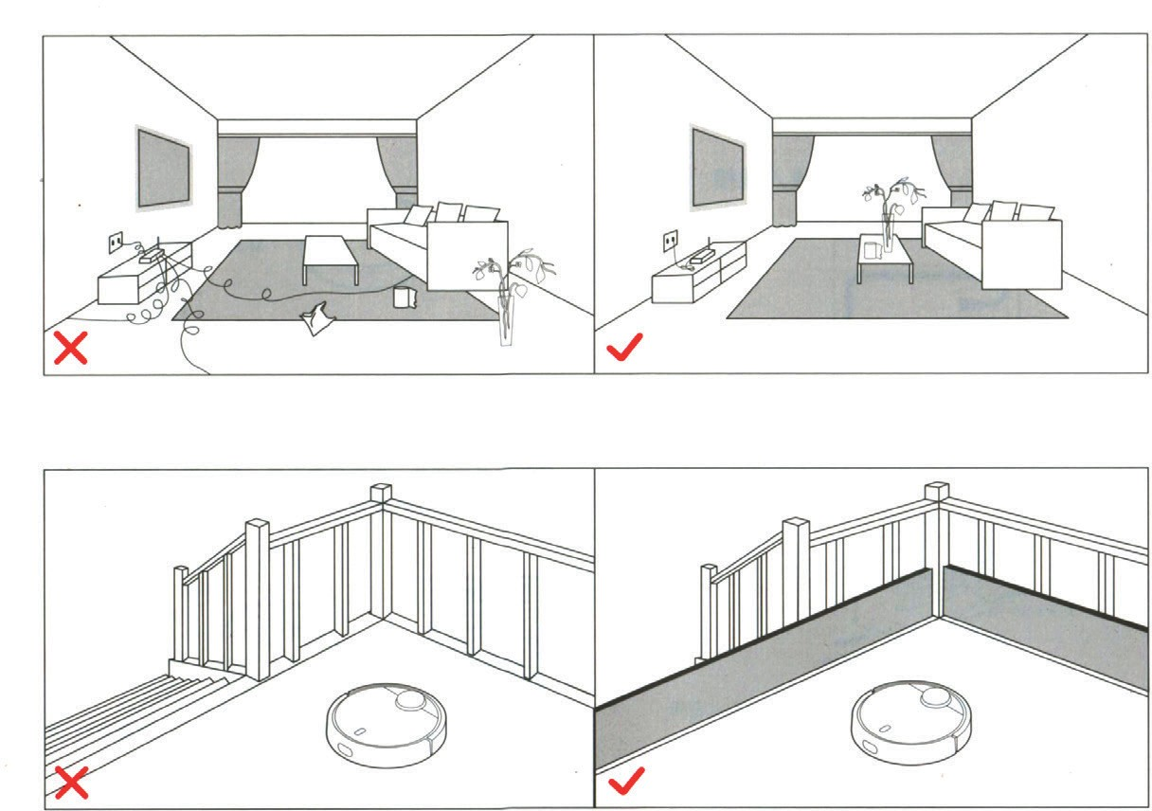Before using the product, please carefully read this manual and save it properly

Caution
Before you start cleaning, make sure, that there were no wires and foreign objects on the floor, which are easily overturned, broken or valuable items that may be damaged, or that may be confusing the unit, because of which stucking, collision or whatever may happen way prejudiced person and property.

If the device is used in a space, where there is a height difference, take care of a reliable
physical protection - anti-fall device screen, to prevent damage to people and property.

Attention! During a first cleaning, please follow the device personally, and help him in emerging issues - after issues such cleaning is hassle-free. If there are some areas, that do not require cleaning, and the unit can get stuck in them, get a virtual barrier that will deter the unit from entering the above-mentioned areas.

- Connect power cable. Excess of cable is pulled into the housing trough.

Attention! Power cord, hanging down on the floor, can be entangled by the cleaner, or
removed from the power outlet, which will cause power interruption.

- On a flat surface set a charging base and connect it to power supply.

Note: Make sure that both sides of a charging base have at least 0.5 m, and front surface has at least 1.0 m of free space.

Turning and charging the device.
Press and hold the O button, wait for the ring lamp lights up and press the device to a charging base.

Colour of ring indicator lamp shows an amount of electric charge:
White - 50%;
Yellow - 50% -20%;
Red - less than 20%.
Attention! At too low battery level you can not turn on the device, in this case, please press the device to a charging base.

QR code

Fing «Mi Smart Home» App on the manufacturer’s page or scan two- dimensional code and download the mobile app, open the lid of the device and search for Wi-Fi status indicator lamp. Follow the instructions in the application.

Wi-Fi status indicator
Slow flashing: Waiting for connection; Fast flashing: There is a connection; Continuous combustion: Wi-Fi connection.

Attention! When phone is not connected to a robot cleaner, see «Operating Instructions» -.
«Reset Wi-Fi».

Start Cleaning.
When the round charging indicator finishes blinking white light in the respiratory rate and glows white steady light, it indicates that the device is charged. In this case, briefly press the O button or start the device with a mobile phone.

Thank you for choosing «MiJia» robot cleaner.

«MiJia» robot cleaner - the clever device, which plans a route of cleaning, it is equipped with highly sensitive optical laser and ultrasonic sensors, measuring a distance, and in real-
time can build a plan of a room; using space sensors, scanning cleaning route, so cleaning is performed a complete, comprehensive, high-performance.
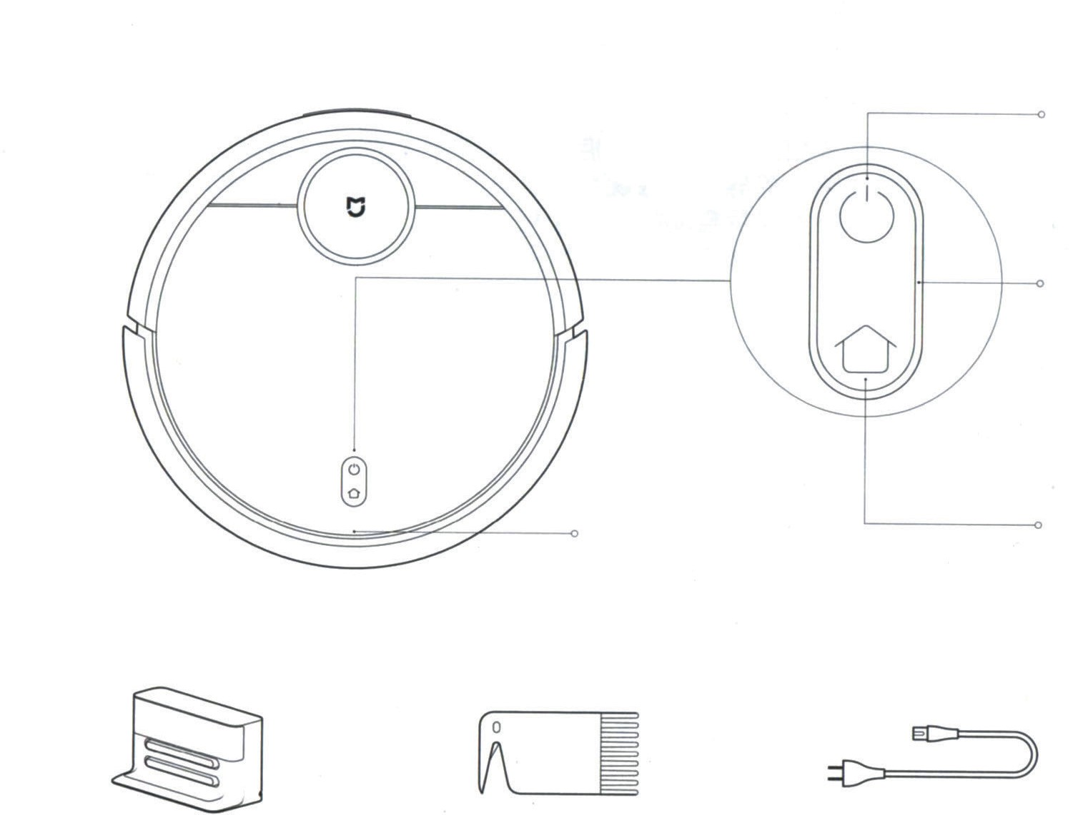Cleaning can be carried out in difficult spaces, after cleaning the unit automatically returns to charging, while working, he does not require human attention. You can also remotely
control the device, using mobile application, you can see see cleaning scheme and its condition, set cleaning schedule in this one.
Science and technology are changing lives. Starting today, you and your family free from a hassle of cleaning the floor. Enjoy the pleasures of life, use the device with pleasure!

Main device

Lifting cover
Cleaning / On/Off
Start cleaning by short pressing.
Long pressing - On/Off the device.

Ring indicator lamp;
White color: battery level more than 50%; Yellow: 50% - 20%;
Red: battery level less than 20%;
Blinking in the respiratory rate: recharge or run; Fast flashing red: alarm condition.

Return for charging / partial cleaning.
Make a short press the button to return to the charging. Long press activates a partial cleanup.

Charging base Brush cleaning device Power cable

Attention! If during cleaning, recharging or partial cleaning, press any button, all the action of the vacuum cleaner temporarily stops.

Overview

Main device

Dust collector

Charging base

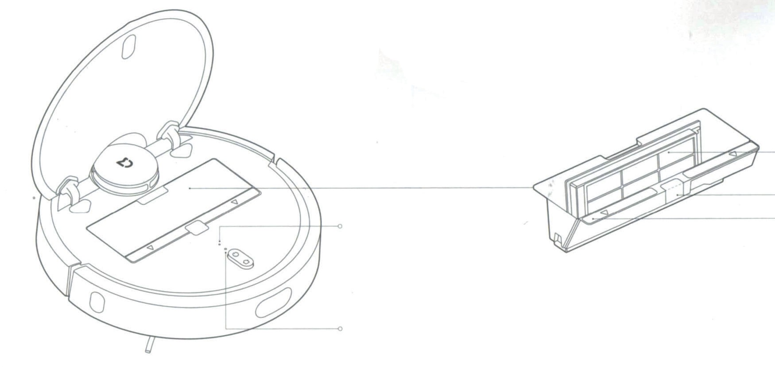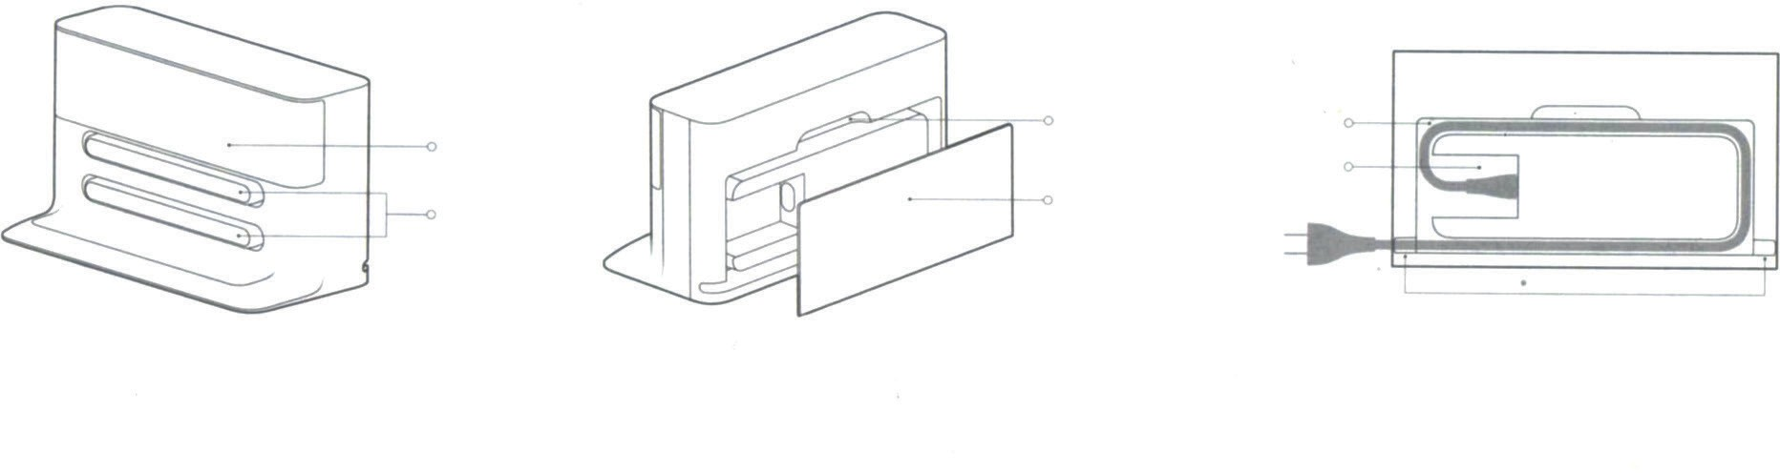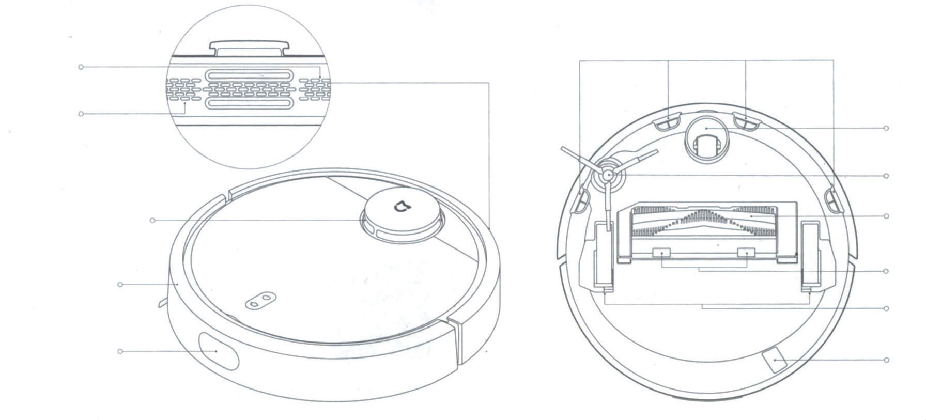Reset button

Dust collector cover

Indicator light Wi-Fi Slow flashing: Standby connection;
Fast flashing: there is a connection;
Continuous combustion: Wi-Fi connection has occurred.

Filter grid

Dust collector clamp

Identification zone

Charging contacts

Clamp

Back cover

Cable housing Power cable
socket

Cable outlet
Attention! The cable can be
removed, both right and left.

Sensor of hovering
Speaker

Air outlet holes

Anti-shok buffer

Ultrasonic sensor

Laser rangefinder
Wheel Side brush

Main brush
Main brush lid clamp Main wheels

USB port for settings

Usage

  - 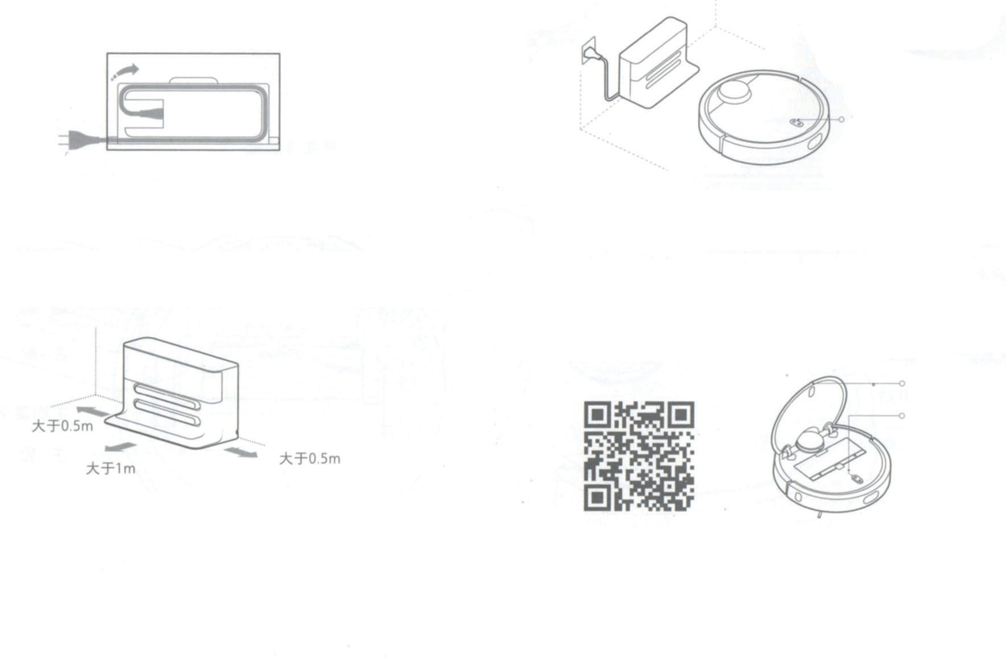Connect power cable. Excess of cable is pulled into the housing trough.

Attention! Power cord, hanging down on the floor, can be entangled by the cleaner, or removed from the power outlet, which will cause power interruption.

Colour of ring indicator lamp shows an amount of electric charge:
White - 50%;
Yellow - 50% -20%;
Red - less than 20%.
Attention! At too low battery level you can not turn on the device, in this case, please press the device to a charging base.

Top lid

Wi-Fi status indicator

  - On a flat surface set a charging base and connect it to power supply.

Note: Make sure that both sides of a charging base have at least
0.5 m, and front surface has at least 1.0 m of free space.

Turning and charging the device.
Press and hold the O button, wait for the ring lamp lights up and press the device to a charging base.

5. Start Cleaning.
  - QR code

Fing «Mi Smart Home» App on the manufacturer’s page or scan two-dimensional code and download the mobile app, open the lid of the device and search for Wi-Fi status indicator lamp. Follow the instructions in the application.

Wi-Fi status indicator
Slow flashing: Waiting for connection; Fast flashing: There is a connection; Continuous combustion: Wi-Fi connection.

Attention! When phone is not connected to a robot cleaner, see «Operating Instructions» -. «Reset Wi-Fi».

When the round charging indicator finishes blinking white light in the respiratory rate and glows white steady light, it indicates that the device is charged. In this case, briefly press the O button or start the device with a mobile phone.

Usage

On/Off

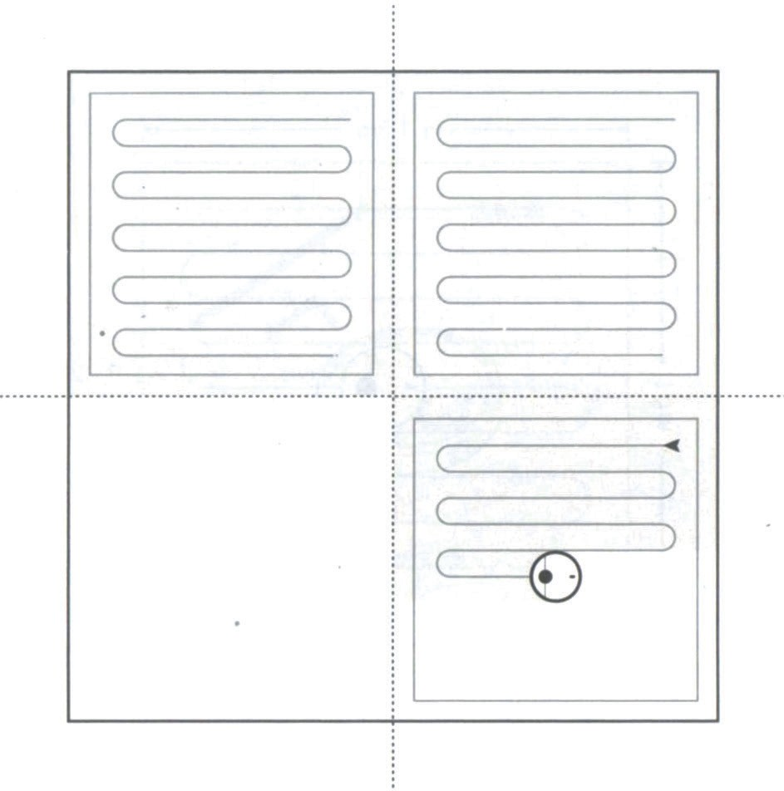Long press O button and the device is turned on, indicating ring lamp lights up and the cleaner listens for commands. When the appliance is in standby (quiescent), long press O button to switch off, cleaning is finished.

Attention! it is impossible to turn off the device during charging.

Cleaning.

After short pressing O button cleaning starts (cleaning algorithm, see the diagram on the right). Pressing any button during cleaning comes a pause mode.

Caution!

At too low a charge is impossible to start cleaning up, please charge the device and start again.
When, during the cleaning, a battery level falls below a critical line, the unit automatically returns to base to recharge, after the recharge to an acceptable level , it automatically returns to a place, where cleaning was interrupted, and continues it.

Before cleaning, please make sure, that no wire on the floor (including power cable from a charging station), to prevent them tangling the device and pulling them out of the network, damage wires and objects.
If cleaning is finished in less than 10 minutes, it is performed again by default.

Charging.

Auto: After cleaning, the unit automatically returns to base to recharge.

Manual: During pause, quickly press «Home» button, then the unit returns to base to
recharge and ring indicator lamp starts flashing slowly.

Note!

If the device is unable to find a charging base, help him manually.

Cleaning algorithm

After starting a cleaning, the device performs its intellectual scheme of scanning, along
the walls, dividing the space into zones, building zones of cleaning route as Latin letter Z.

When the cleaner have finished cleaning in one area, it moves to the next with no gaps. When the entire cleaning is finished, the device automatically returns to base to recharge.

Zone 1 - already cleaned Zone 2 - already cleaned

Zone 4 - awaiting for cleaning Zone 3 - now cleaning

Partial cleaning

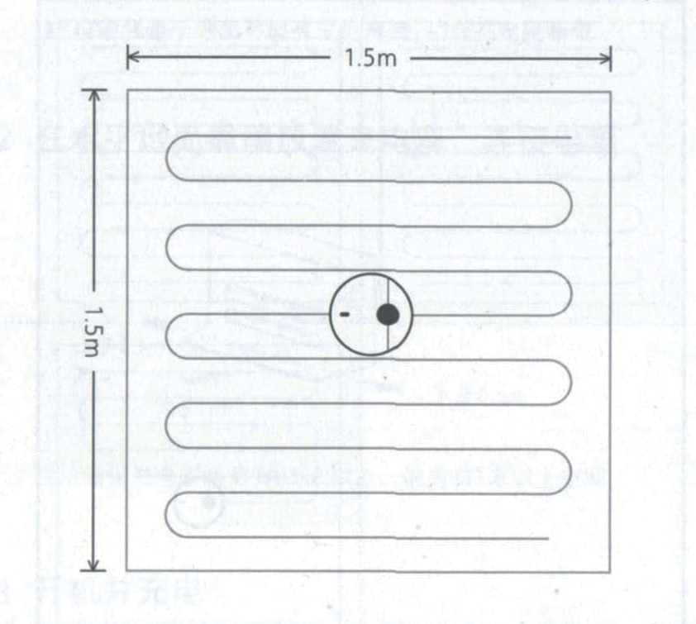While the device is in standby or pause, long press «Home» button, a partial cleaning automatically begins; its algorithm is cleaning zone 1,5 m x 1,5 m around the device, after the vacuum cleaner automatically returns to the starting point of partial harvesting and goes to stop mode.
Attention! If during a partial turn pause mode, cleaning will be completed.

Pause

During a movement of device, press any button.
When you click O button, cleaning continues. When you press «Home» button, unit returns to base to recharge and cleaning will be completed.
Note: If, during a pause, you press the device to a charging base, cleaning will be completed.

State of accident

When, during the motion of the device, fault occurs, ring light indicator starts rapidly flashing red, accompanied by a voice indication. Ways to solve emergency problems, see. «Solving problems upon detection of faults.»

Note!

If an alarm condition occurs, and the device not taken more than 10 seconds, it automatically goes into sleep mode.
If in event of an emergency condition, press the device to charging base, the cleaning will be completed.

Sleep mode

If the unit does not operate for more than 10 seconds, it automatically goes into sleep
mode. A ring light indicator flashes red once per second.
If, during sleep, press any button, the device can be awakened.

Note!

During charging on a basis, the device may not enter Sleep mode.
After 12 minutes in Sleep mode, it automatically turns off.

Planning of cleaning

Using the mobile app, you can schedule cleaning for some time, and the unit will automatically start cleaning at a selected time, and after automatically return to base to recharge.

Wi-Fi Reset

When, for hardware reasons, or if you have forgotten Wi-Fi password, etc., you can not connect and operate the device, using a mobile phone, open an upper hinged cover, and then you will see a Wi-Fi status indicator, simultaneously press and hold the buttons O and «Home», at this time you will hear a voice command «Reset Wi-Fi». Wait, till indicator flashes slowly again, restart was successful.

Cleaning algorithm

With the mobile app, you can choose a quiet, normal and energetic cleaning mode. By default, the standard mode.

DND mode

In «Do Not Disturb» mode the instrument can not continue to clean and speech
means informs about it. Frequency of ring indicator flashing reduced. «Do Not Disturb» mode configured to 22.00 to 08.00 by default. With the mobile application mode «Do not disturb» You can enable or reprogram his time ..

Virtual barrier

This is a non-standard addition, can be purchased at www.mi.com
Virtual barrier can be used to limit the location of undesirable areas for the device, for example, dangerous changes in levels, steps, places where it is possible jamming device.
Attention! Very carefully and firmly attach barriers, that they do not come unstuck, otherwise their application will be ineffective.

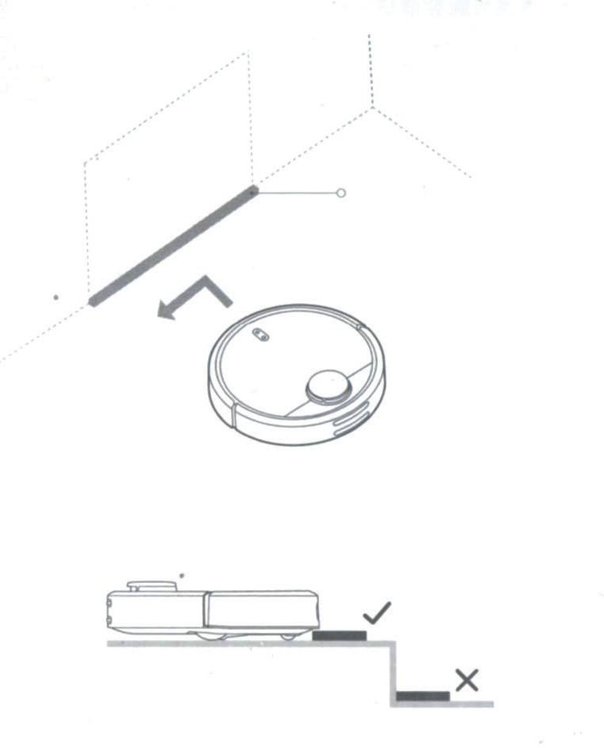

Virtual barrier

Attention! Place virtual horizontal barriers on the way of the device.

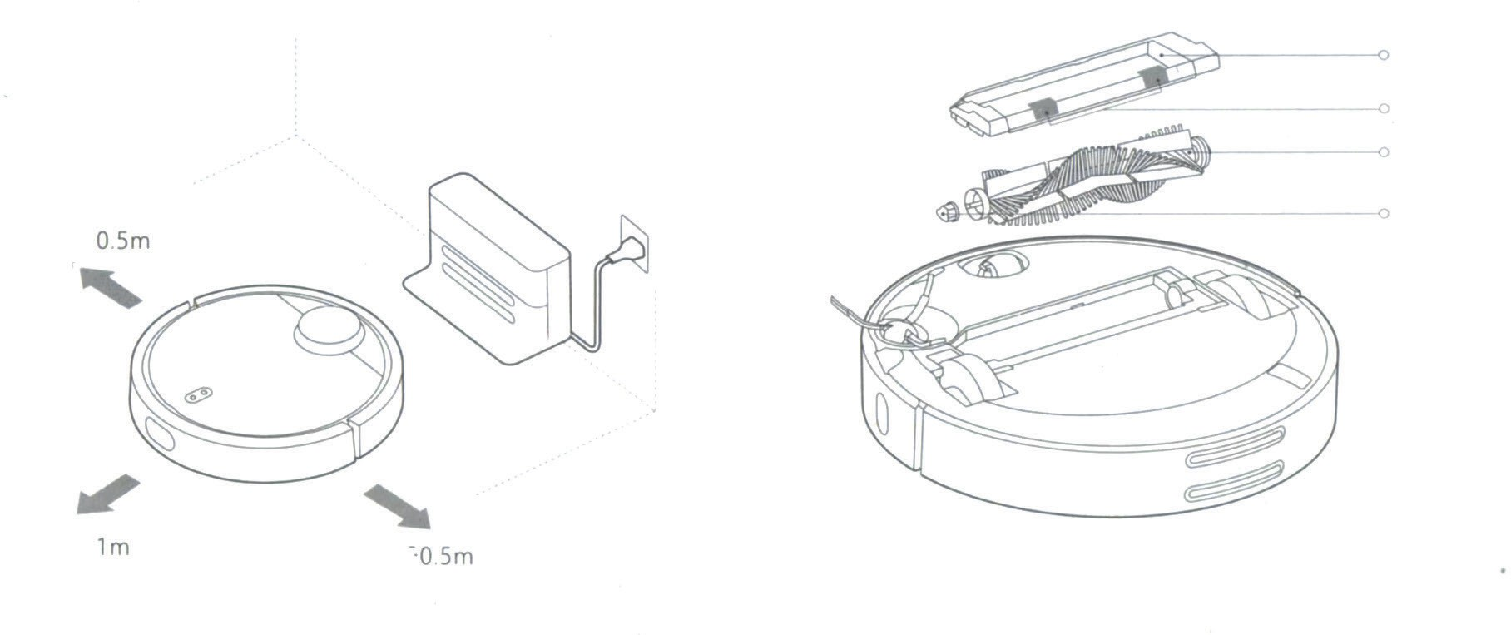Charging base

Base for recharging should be placed on a flat surface, leaning to wall, providing each side of not less than 0.5 m, and in front of at least 1.0 m of free space, and attached to a power outlet. To ensure satisfactory reception of Wi-Fi mobile phone, its position in the area of good signal.

Attention! Do not place the recharging base in the areas of direct sunlight or in places, where access to it is difficult, and there can be problems with the device for return to the recharging base.

Daily care

Main brush. Weekly cleaning recommended

- Click on a tab at the bottom of the device and remove a main brush;
- Pull a main brush and clean bearings of the main brush;
- Clean hair, tangled on the main brush, using a tool to clean the main brush that is included;
- Replace the main brush and secure it with the cover latch.

Note!

It recommended for cleaning effectiveness every 6-12 months change the main brush

Main brush cover Latch
Main brush

Main brush bearings

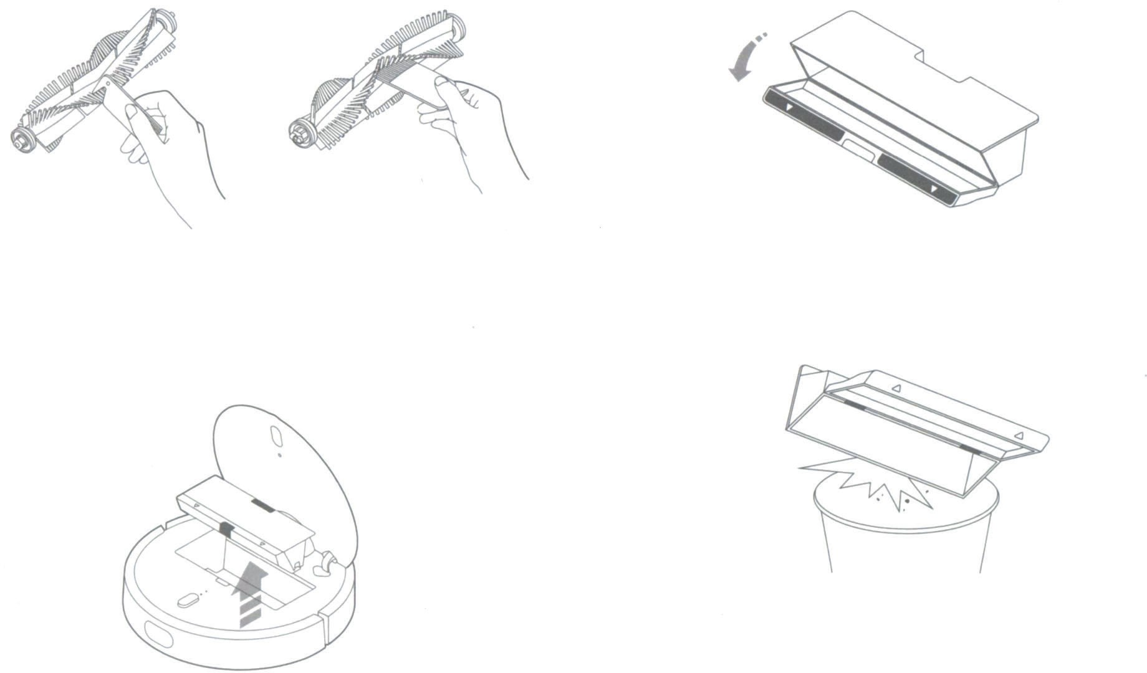

A method of cleaning the main brush with supplied tool.

Dust collector and filter grid
It is recommended to clean weekly.
  - Lift a top cover of the device, press a latch and pull a dust collector.

Daily care

  - Open the front cover of the dust container

  - Empty trash from the dust collector

Attention! To avoid clogging the filter mesh, please knock on the
dust collector, emptying trash.

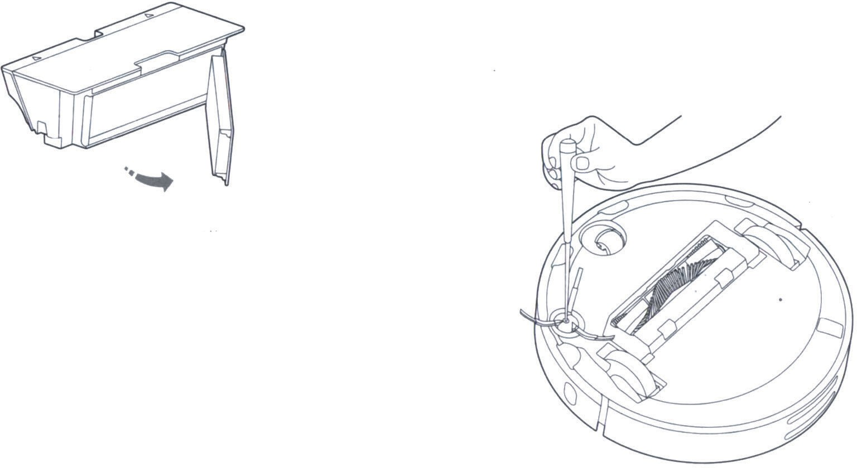Filter grid can not be washed with water, otherwise it becomes clogged with dust, and
it will affect a cleaning efficiency.
Attention! It is recommended to be changed filter grid every 3 months to ensure cleaning efficiency.

Remove and change a filter grid, as illustrated

Battery

The device used a powerful high-performance lithium-ion battery pack; during daily use
of the device, please watch a battery status.

Attention! If the device is not used for a long time, during storage of the device at least
once in 3 months to charge a battery to prevent abnormal discharge of batteries.

The side brush should be cleaned monthly

- Turn off the device and remove a side brush mounting screws;
- Pull out and clean a side brush;
- Place a side brush back and tighten the screws.

Attention! It is recommended every 3 - 6 months change a side brush to ensure cleaning efficiency.

Turning wheel; «360 degrees»
recommended to clean daily

  - Turn off the device and remove turning wheel;
  - Clean a wheel and its bearings from hair and sticky substances;
  - Fit a wheel back.

Sensors of the device
recommended to clean monthly

Use a clean cloth to clean all sensors of the cleaner, including:

- Four sensor hovering over a bottom rung of the device;
- The motion sensor along a wall at the right of the device;
- Charging contacts at the back of the device.

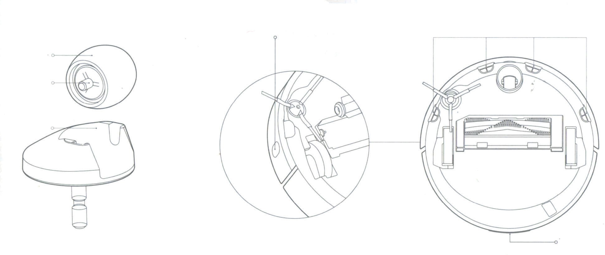

Hovering sensor Support

Wheel

Bearing of a wheel

Sensor of motion along a wall

Charging contacts

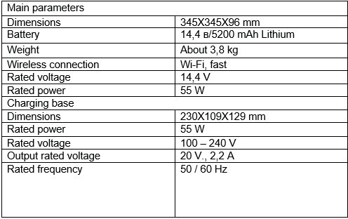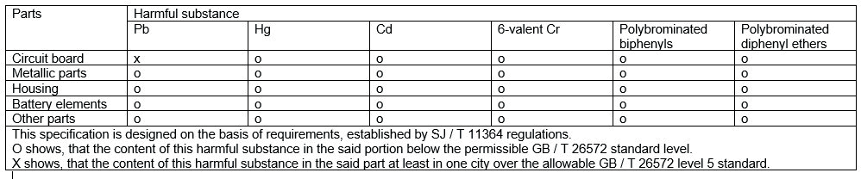Charging base
recommended to clean monthly Use a clean cloth to clean contacts.

Software update

Use an mobile app to update the device’s software, before update, make sure that charge is at least 20%.
When you update a software, ring indicator light quickly flashes white.

System reset

If there is no response on pressing buttons or inability to turn off the device, please try to reboot the system by pressing a system reset button (see. Section 2), and the unit will automatically start again.
Attention! Rebooting the system will destroy properties of scheduled cleanings and cleaning modes and also to reboot the Wi-Fi connection.

Reset to factory settings

If, after reboot, normal operation of the device is not restored, press and hold
«Home» button and simultaneously press once a system reboot button, you will hear a voice message «Return to initial factory settings» and system will return to factory settings.

The name and contents of harmful substances

Troubleshooting
In the event of emergency situations, a ring indicator light flashes red rapidly and you will hear a voice message. In this case, please review contents of the table and fix
a problem.

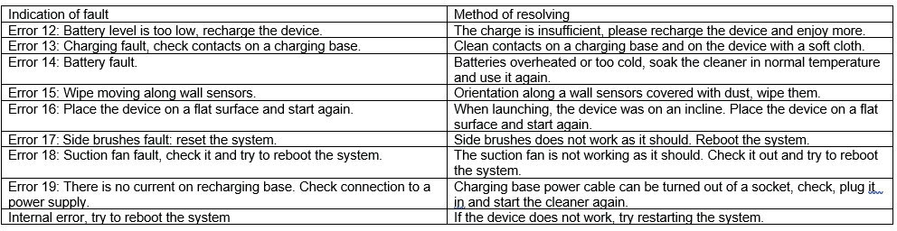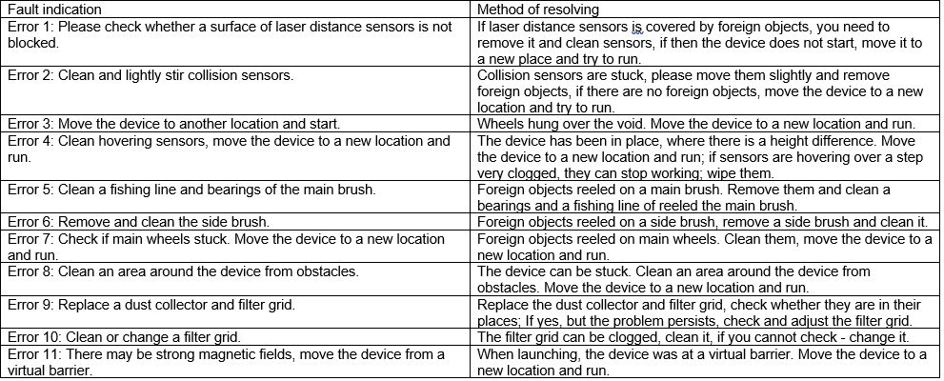System reset should solve some problems

Information about safety

Information about dangers of laser light: Laser distance measurement sensor on this unit complies with IEC 60825-1: 2014 Product type 1, and causes no harmful laser
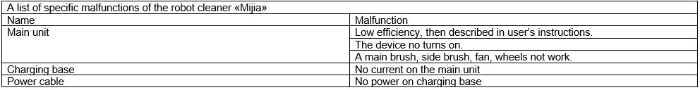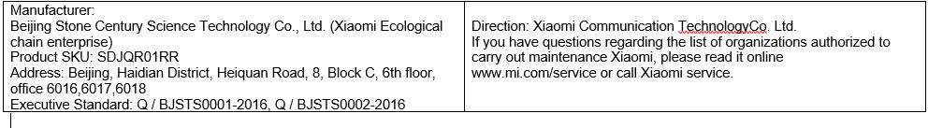radiation.

Executive Standard: GB 4706.1-2005, GB 4706.7-2005, GB 4343.1-2009, GB17625.1-2012, Q / BJSTS0001-2016, Q / BJSTS0002-2016

The list of possible malfunctions of the robot cleaner «MiJia»

XIAOMI-MI.COM

